Artificial Intelligence for Educators
Author: Assoc. Prof. Emre Dandıl

Purpose
To provide teachers with foundational knowledge and practical understanding of Artificial Intelligence (AI) and its educational applications.

Learning Outcomes
At the end of this Module participants will be able to:
- Explain the basic concepts of AI.
- Distinguish between AI, Machine Learning and Deep Learning.
- Use generative AI tools for educational purposes.
- Evaluate opportunities and risks of AI in education.
- Design AI-supported learning activities.

Table of Contents
Purpose 2
Learning Outcomes 2
1. Introduction to Artificial Intelligence 4
1.1. Types of Artificial Intelligence 6
1.2. Current Trends in Artificial Intelligence 6
1.3 Artificial Intelligence in Education 7
2. Machine Learning and Deep Learning 10
2.1. What is Machine Learning 10
2.2. Types of Machine Learning 11
2.3. What is Deep Learning? 12
2.4. Artificial Neural Networks 13
2.5. Deep Neural Networks 14
2.6. Deep Learning Architectures 14
2.7. Applications in Education 15
2.8. Applications in Agriculture 15
3. Generative AI for Teachers 19
3.1. Applications in Teaching 19
3.2. Writing Effective Prompts 20
4. Ethical and Responsible AI 23
4.1. Evaluating AI-Generated Content 23

Introduction to Artificial Intelligence
Artificial intelligence (AI) has emerged as one of the most transformative technologies of the 21st century. It has fundamentally changed the way individuals work, communicate, learn, and make decisions (Organisation for Economic Co-operation and Development, 2019). Advances in computational power and the availability of large-scale datasets, coupled with breakthroughs in machine learning algorithms, have enabled AI systems to perform tasks that previously required human intelligence. These include speech recognition, language translation, image interpretation, decision support, autonomous navigation, and content generation (Russell & Norvig, 2020). Unlike conventional software, which follows predefined rules developed by programmers, AI systems can learn from experience, adapt to new information, and improve their performance over time. This ability enables AI to solve complex problems in dynamic environments where traditional rule-based programming is often inadequate.
The scope of AI's impact extends far beyond computer science. It has become an enabling technology in many different sectors, including healthcare, agriculture, manufacturing, transport, finance, and education. In educational settings, for example, AI can support personalized learning, intelligent tutoring systems, automated assessment, learning analytics, and content generation. This offers educators new opportunities to improve the effectiveness of their teaching and learner engagement (Holmes & Miao, 2023).

Figure 1. Relationship between artificial intelligence, machine learning, deep learning, foundation models, and generative AI
In agricultural education, AI provides significant opportunities to prepare future professionals for digital agriculture and precision farming. Teachers with AI expertise can incorporate emerging technologies into their teaching methods, helping students to develop the digital skills required by modern agricultural industries.
Artificial intelligence can be defined as the capacity of a machine to perform tasks that would normally require human intelligence, including learning, reasoning, problem solving, language understanding, and visual perception (Russell & Norvig, 2020). Conventional software follows fixed instructions written in advance and cannot operate beyond them. AI systems differ fundamentally: they analyze data, identify patterns, learn from experience, and generate predictions or decisions with limited human intervention. Rather than being programmed with every rule explicitly, an AI system is trained on representative examples from which it derives its own rules.
As seen in Figure 2, the conceptual foundations of AI date back several decades. In 1950, the mathematician Alan Turing posed the question of whether machines could think and introduced the Turing Test as a criterion for determining whether a machine could exhibit intelligent behaviour indistinguishable from that of a human (Turing, n.d.). In 1956, at the Dartmouth Conference in the United States, the computer scientist John McCarthy formally named the field and defined artificial intelligence as the science and engineering of making intelligent machines (McCarthy et al., n.d.).
In subsequent decades, the field matured considerably. During the 1980s, expert systems that encoded specialist knowledge as explicit rules became widely used. In 1997, IBM's Deep Blue defeated the world chess champion Garry Kasparov, demonstrating that machines could surpass humans in narrowly defined domains. A more significant shift occurred during the 2010s, when lower-cost computing power and the large volumes of data generated by the internet enabled the rise of deep learning and produced substantial improvements in tasks such as image recognition and machine translation. The public release of ChatGPT in 2022 brought AI beyond specialist laboratories into every day use for millions of people (Melanie. Mitchell, 2019). Today, AI operates within search engines, recommendation systems, voice assistants, autonomous vehicles, medical diagnosis, and educational technologies.
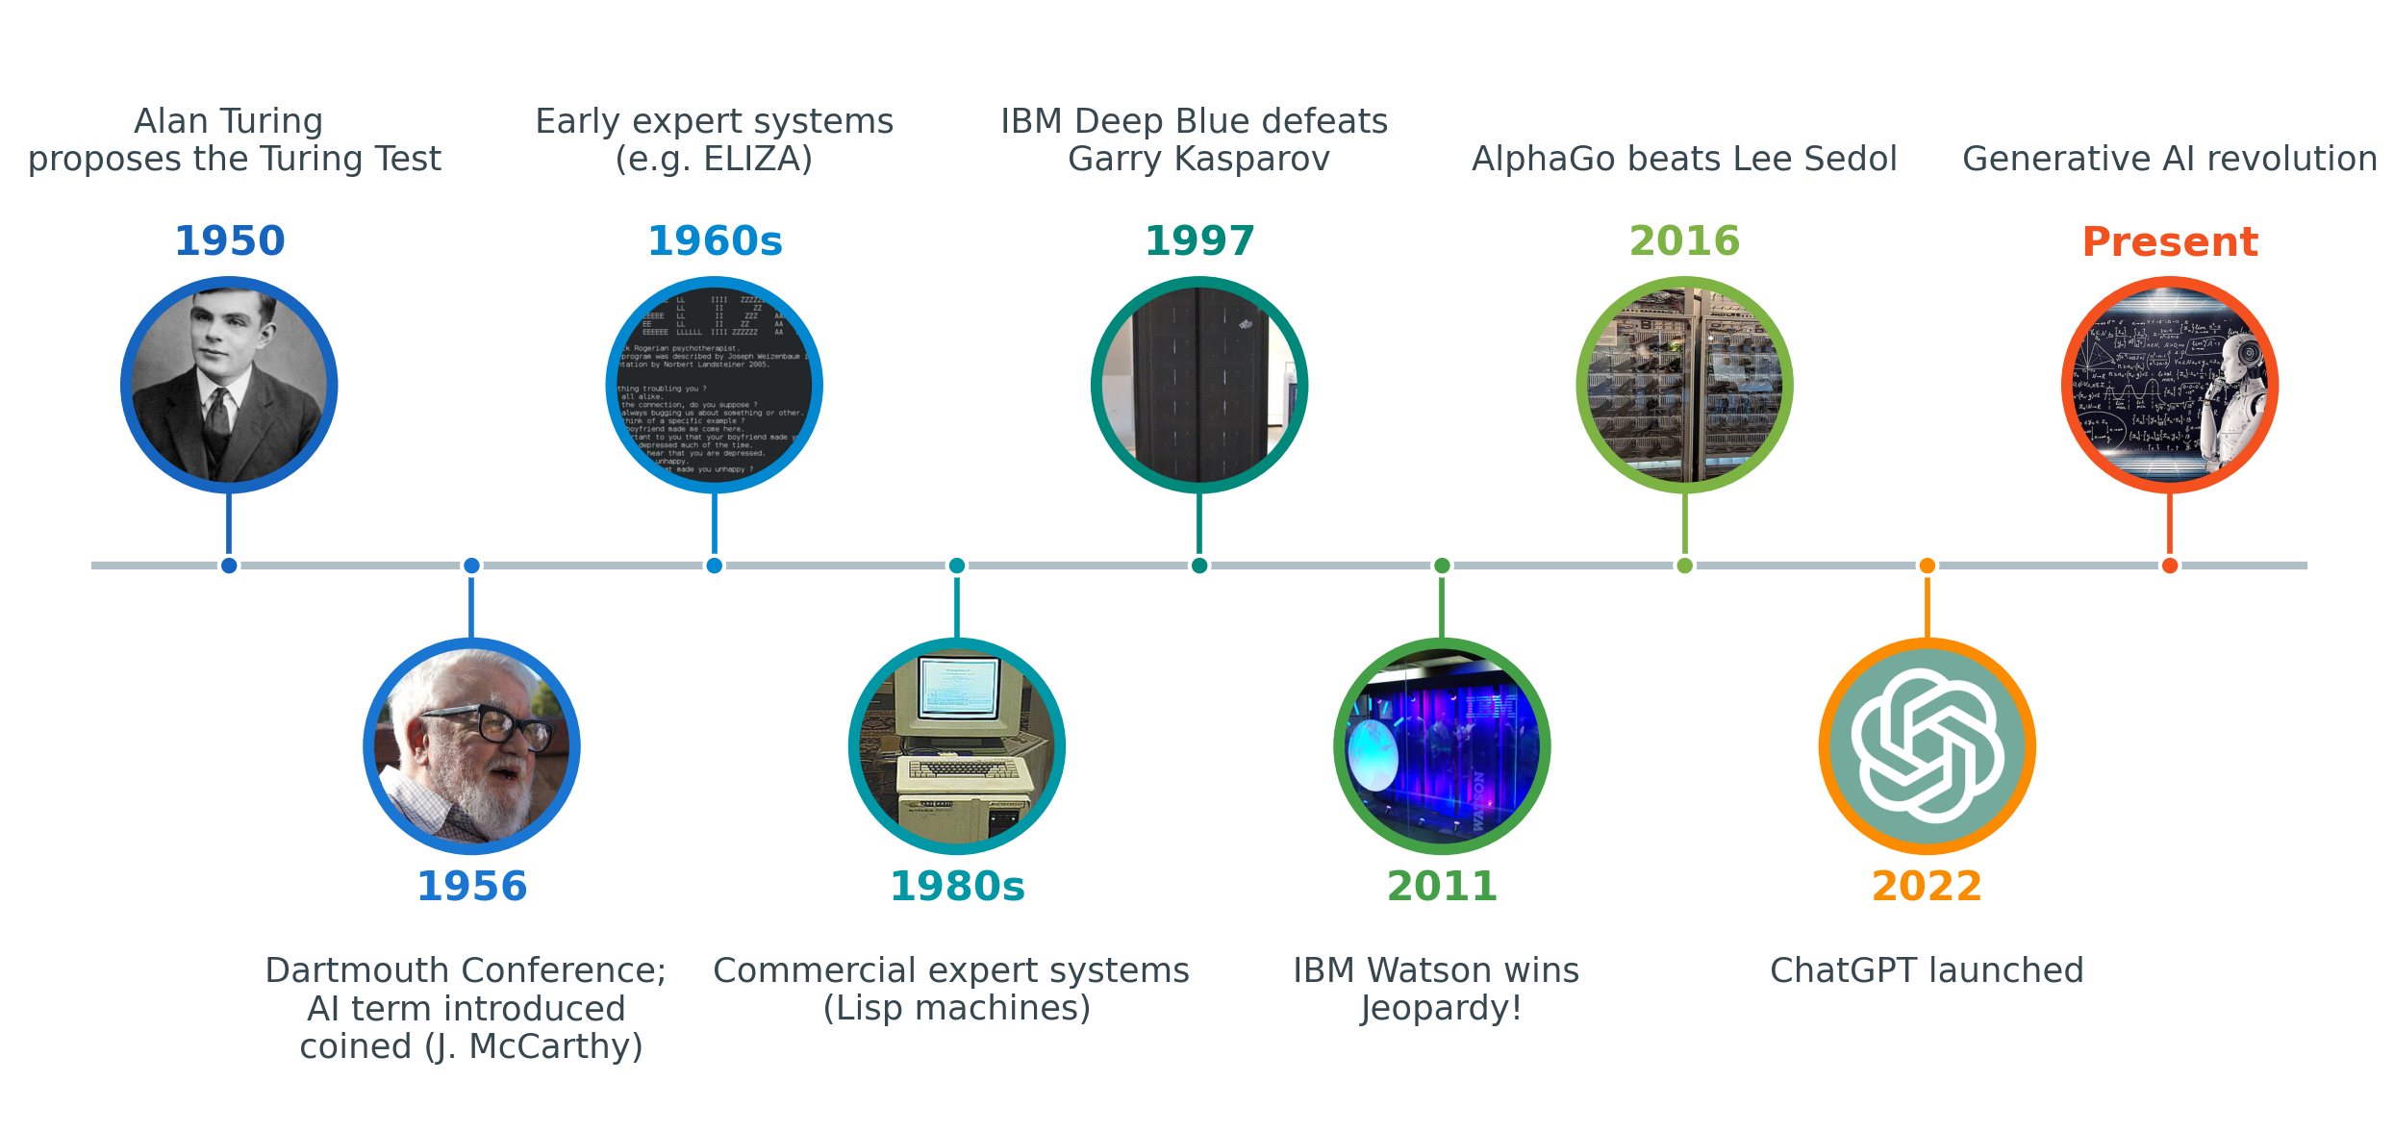
Figure 2. Milestones in the development of artificial intelligence

1.1. Types of Artificial Intelligence
Although AI is often portrayed as a single, all-powerful entity, systems in practice differ considerably in their level of capability (Schmid et al., 2021). Distinguishing between these levels helps separate realistic expectations from exaggerated claims. AI is commonly classified into three categories.
- Narrow Artificial Intelligence (Weak AI): Almost all AI systems in use today fall into this category. Such systems are designed to perform a specific task to a high standard but cannot operate outside it. Common examples include Google Translate, voice assistants such as Siri, facial-recognition systems, and recommendation engines. A system capable of defeating a world chess champion, for example, cannot perform any unrelated task for which it was not designed.
- Artificial General Intelligence (Strong AI): This refers to a hypothetical system capable of performing any intellectual task that a human can perform, adapting across different domains, and learning independently at a human level of reasoning. Artificial general intelligence does not currently exist and remains an active goal of ongoing research.
- Superintelligence: A hypothetical form of AI that would surpass human intelligence in every domain, improve its own capabilities, and make advanced scientific discoveries. At present, it remains a theoretical concept with no real-world example.
Some experts classify AI into four categories based on its functionality (Philipo et al., 2025):
- Reactive Machines: Systems with no memory that merely react to the current situation. (IBM Deep Blue)
- Limited Memory: Systems capable of learning to a limited extent from past experiences. (autonomous vehicles)
- Theory of Mind: Hypothetical systems capable of understanding emotions and intentions.
- Self-Awareness: Conscious machines; these have not yet been developed.

1.2. Current Trends in Artificial Intelligence
Recent developments have significantly accelerated the adoption of artificial intelligence. Within only a few years, capabilities that were once limited to specialized research groups have become widely accessible tools used across many professions and in everyday life. This rapid diffusion has been accompanied by the maturing of several distinct branches of AI, each addressing a different type of problem and each finding practical uses in sectors such as healthcare, industry, education, and agriculture. Important trends include:
Generative Artificial Intelligence: Systems that generate new outputs, such as text, images, audio, video or code, in response to user input. ChatGPT, Google Gemini, and Microsoft Copilot are among the most widely used examples (Kasneci et al., 2023). In agriculture, generative models are already being tested as advisory tools: large language models can translate complex scientific findings into simple, location-specific guidance for farmers, for example by generating tailored crop-management recommendations (Tzachor et al., 2023).
Computer Vision: Technology that enables machines to interpret and analyze visual information (Salari et al., 2022). Typical applications include medical image analysis and the perception of the surrounding environment by autonomous vehicles. In agriculture, computer vision is widely used to identify plant diseases from leaf images; deep learning models trained on large image datasets achieve high accuracy in distinguishing healthy and diseased crops, offering farmers a cost-effective diagnostic tool (Mohanty et al., 2016).
Natural Language Processing (NLP): Technology that enables machines to understand and generate human language. Chatbots, virtual assistants, and real-time translation systems are typical applications. In agriculture, NLP and text-mining techniques are used to extract knowledge from research reports, field records, and advisory messages, and to power multilingual chatbots that answer farmers' questions and act as around-the-clock virtual extension officers (Drury & Roche, 2019)
Robotics and Automation: AI-enabled robots are increasingly used in manufacturing, healthcare, and logistics, where they perform repetitive or physically demanding tasks. Agriculture is one of the fastest-growing areas of application: autonomous machines now carry out field operations such as precision weeding, selective harvesting, and crop monitoring, helping to address labour shortages and reduce the use of chemical inputs (Bechar & Vigneault, 2016).

1.3. Artificial Intelligence in Education
Artificial intelligence is also changing everyday educational practice, and it offers teachers considerable practical support. Used thoughtfully, it can take over some routine tasks and give teachers more time to focus on their students (European Commission, 2022). It works best as an assistant that complements the teacher's professional judgement. Its main areas of application in education include (Cukurova & Miao, 2024; U.S. Department of Education, 2023; Zawacki-Richter et al., n.d.):
- Personalized Learning: AI can adapt the content, difficulty, and pace of learning to the needs of each student, offering additional support to those who are struggling and greater challenge to more advanced learners (Mario et al., 2025).
- Automated Assessment: AI can grade quizzes, carry out preliminary evaluations of assignments, and provide instant feedback, thereby reducing the teacher's routine marking workload and enabling quicker responses to students.
- Content Creation: Teachers can use AI to produce initial drafts of lesson plans, examination questions, presentations, and learning activities which they then review and refine before use.
- Learning Analytics: By analyzing student performance, engagement levels, and possible learning difficulties, AI can give teachers early warnings about learners who may need help, along with useful insights for adjusting their teaching.
Learning Activities and Resources
Discussion: How is AI changing education?
In small groups, identify where AI already appears in your students' daily lives and in your own teaching. Share one example in which AI could support your subject area, and one concern it raises.
Reflection A teacher uses ChatGPT to prepare lesson plans and quizzes. Discuss:
• What benefits does AI provide in this scenario?
• What risks may arise?
• How can the teacher verify that the AI-generated content is correct and appropriate?
Key Concepts:
Concept | Definition
Artificial Intelligence | Simulation of human intelligence by machines
Machine Learning | AI systems that learn from data
Deep Learning | Neural-network-based machine learning
Generative AI | AI that creates new content
NLP | AI systems that process language
Computer Vision | AI systems that understand images

Recommended Resources
• Elements of AI (free introductory course): https://www.elementsofai.com/
• Microsoft Learn — AI training: https://learn.microsoft.com/training/
• UNESCO — AI and Education: https://www.unesco.org/en/digital-education/artificial-intelligence

References
Bechar, A., & Vigneault, C. (2016). Agricultural robots for field operations: Concepts and components. Biosystems Engineering, 149, 94–111. https://doi.org/10.1016/J.BIOSYSTEMSENG.2016.06.014
Cukurova, M., & Miao, F. (2024). AI competency framework for teachers. UNESCO.
Drury, B., & Roche, M. (2019). A survey of the applications of text mining for agriculture. Computers and Electronics in Agriculture, 163, 104864. https://doi.org/10.1016/J.COMPAG.2019.104864
European Commission. (2022). Ethical guidelines on the use of artificial intelligence (AI) and data in teaching and learning for educators. In Publications Office of the European Union.
Holmes, W., & Miao, F. (2023). Guidance for generative AI in education and research. UNESCO.
Kasneci, E., Seßler, K., Küchemann, S., Bannert, M., Dementieva, D., Fischer, F., ... & Kasneci, G. (2023). ChatGPT for good? On opportunities and challenges of large language models for education. Learning and individual differences, 103, 102274.
Mario, L., Jonathan, P. G., Mayorga, M., & Técnica, U. (2025). Personalization of learning through artificial intelligence: an analysis of adaptive models in digital education. Journal of Information Systems Engineering and Management, 10(30s), 4922.
McCarthy, J., Minsky, M., Rochester, N., Shannon, C. E. (2006) A proposal for the dartmouth summer research project on artificial intelligence, august 31, 1955. AI magazine, 27(4), 12-12.
Mitchell, Melanie. (2019). Artificial intelligence: a guide for thinking humans. 317.
Mohanty, S. P., Hughes, D. P., & Salathé, M. (2016). Using deep learning for image-based plant disease detection. Frontiers in Plant Science, 7(September), 215232.
Organisation for Economic Co-operation and Development. (2019). Artificial intelligence in society. OECD Publishing.
Philipo, A. G., Ding, J., & Ning, H. (2025). From ANI to AGI to ASI: A Comprehensive Review of Capabilities, Challenges, and Future Pathways.
Russell, S., & Norvig, P. (2020). Artificial Intelligence: A Modern Approach, 4/E.
Salari, A., Djavadifar, A., Liu, X., & Najjaran, H. (2022). Object recognition datasets and challenges: A review. Neurocomputing, 495, 129-152.
Schmid, T., Hildesheim, W., Holoyad, T., & Schumacher, K. (2021). The AI methods, capabilities and criticality grid: a three-dimensional classification scheme for artificial intelligence applications. KI-Künstliche Intelligenz, 35(3), 425-440.
Turing, A. (n.d.). Computing Machinery and Intelligence (1950). https://doi.org/10.1093/oso/9780198250791.003.0017
Tzachor, A., Devare, M., Richards, C., Pypers, P., Ghosh, A., Koo, J., Johal, S., & King, B. (2023). Large language models and agricultural extension services. Nature Food 2023 4:11, 4(11), 941–948. https://doi.org/10.1038/s43016-023-00867-x
U.S. Department of Education, O. of E. T. (2023). Artificial intelligence and the future of teaching and learning: Insights and recommendations.
Zawacki-Richter, O., Marín, V. I., Bond, M., & Gouverneur, F. (n.d.). Systematic review of research on artificial intelligence applications in higher education-where are the educators? https://doi.org/10.1186/s41239-019-0171-0

Machine Learning and Deep Learning

What is Machine Learning
Machine learning (ML) is a subfield of artificial intelligence that enables computers to learn patterns from data and improve their performance on a given task without being explicitly programmed to do so (T. M. Mitchell, 1999). In conventional programming, in Figure 3, rules are written by a human and applied by the machine; in machine learning this relationship is reversed, as the system infers the underlying rules directly from the data (Jordan & Mitchell, 2015). Figure 1 illustrates this difference: traditional programming combines data with human-written rules to produce an output, whereas machine learning is given data together with the desired output and derives the rules for itself. A system intended to recognize plant diseases, for instance, is not provided with a description of every symptom, but is trained on large numbers of labelled images of healthy and diseased leaves, from which it learns the relevant distinguishing features.
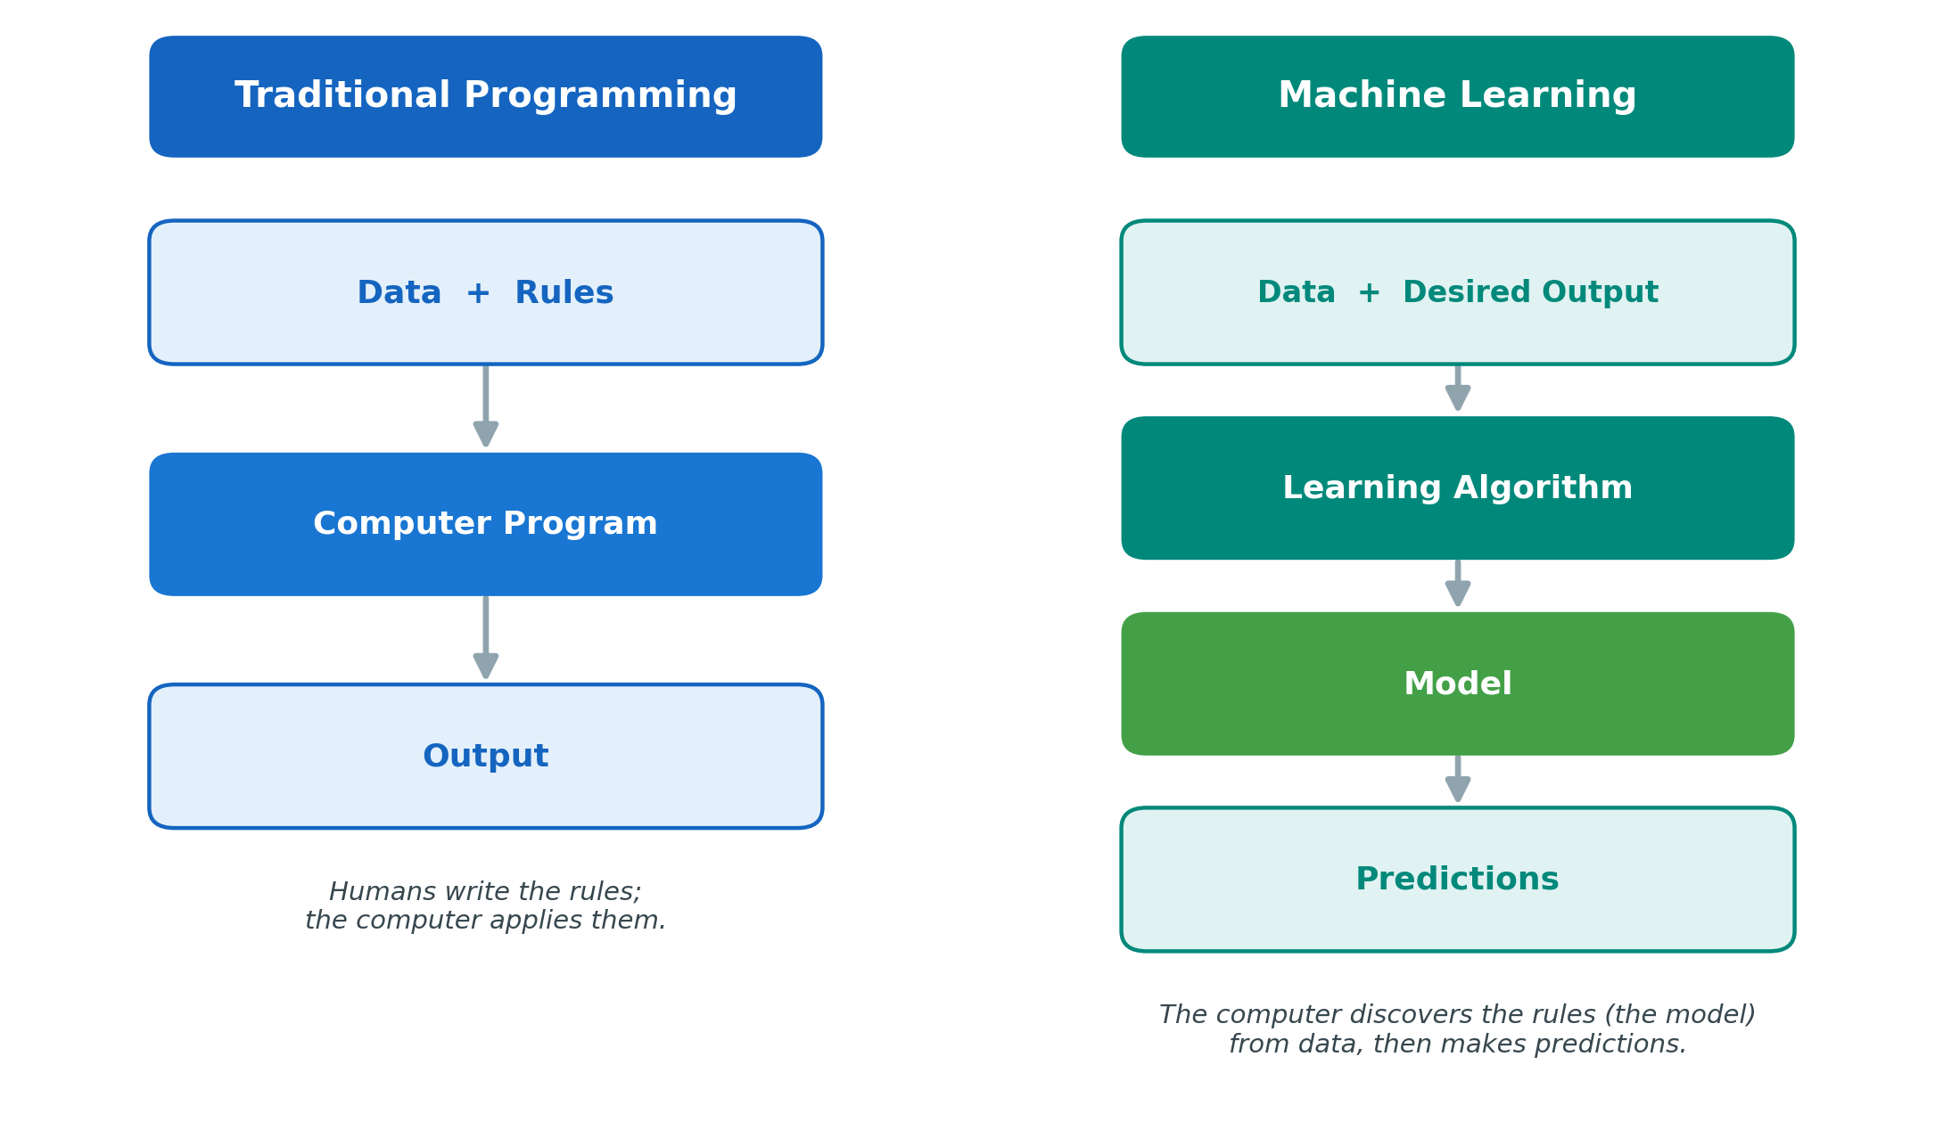
Figure 3. Traditional programming versus machine learning
The significance of this approach lies in the scale of contemporary data. Educational records, meteorological readings, agricultural sensor measurements, and medical images are now generated in volumes that exceed the capacity of manual analysis. Machine learning turns this raw data into useful knowledge and already underpins practical tools in fields as varied as education, healthcare, and agriculture.
Most machine-learning projects follow a common sequence of stages, as seen in Figure 4. Data collection gathers relevant information from sources such as sensors, databases, surveys, or images. Data preparation then cleans this information by removing errors, handling missing values, and, where required, labelling examples. During model training, the algorithm analyses the prepared data and learns the patterns it contains. Evaluation measures the resulting model on previously unseen data, using metrics such as accuracy, precision, and recall. Deployment places the validated model into operational use, for example within a mobile application that assists a farmer in identifying a crop disease in the field. Finally, monitoring tracks the model's performance after deployment and signals when accuracy declines as conditions change, so that the model can be retrained when necessary. The reliability of the final result depends strongly on the earlier stages, since a model cannot exceed the quality of the data on which it is trained (Crespí et al.,, 2025).
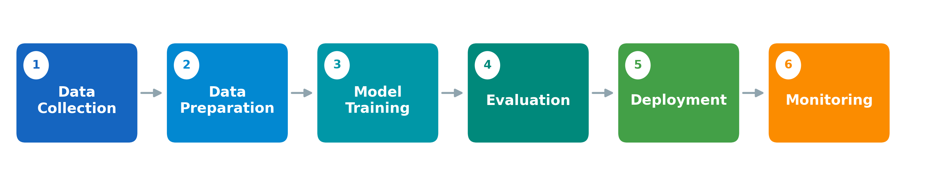
Figure 4. The machine learning lifecycle

Types of Machine Learning
Machine learning is not a single method but a family of approaches, and it is generally divided into three principal categories: supervised, unsupervised, and reinforcement learning (Figure 5). What distinguishes them is the kind of data available during learning and the way in which the system receives feedback on its performance — whether the correct answers are known in advance, must be discovered within the data, or emerge gradually through trial and error (Morales, & Escalante, 2022).

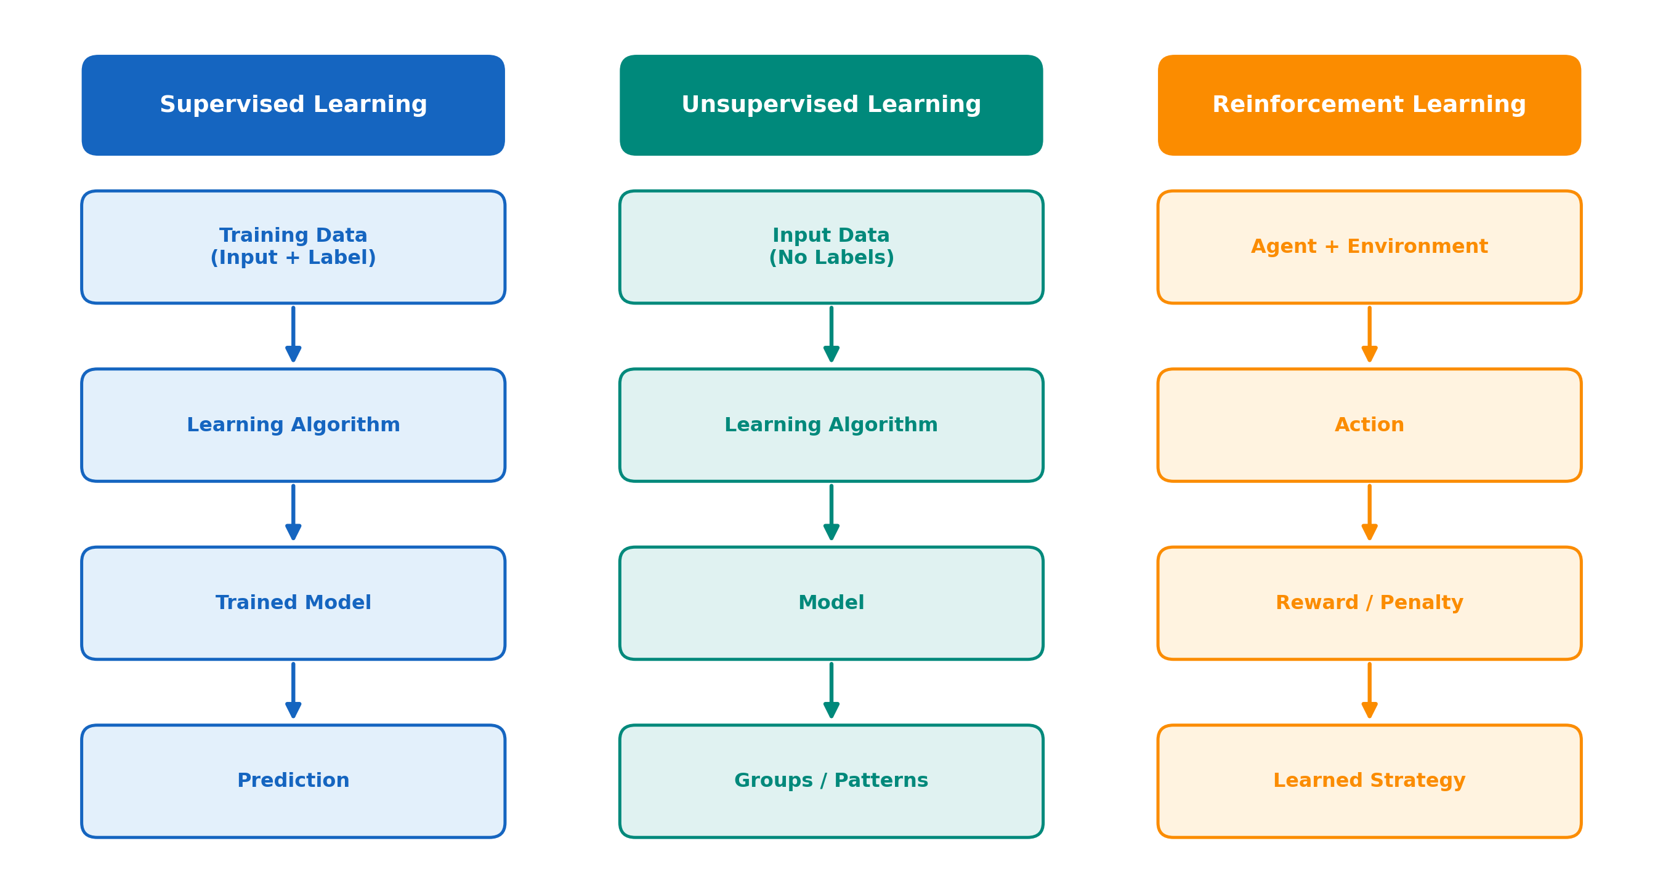
Figure 5. The three types of machine learning and their typical workflows
Supervised Learning: The system learns from labelled data, in which both the input and the corresponding correct output are known. Once trained on a sufficient number of examples, it can predict the correct output for new inputs. Typical applications include spam-email filtering and student-success prediction, while in agriculture supervised learning is widely applied to the identification of plant diseases from labelled leaf images (Mohanty et al., 2016).
Unsupervised Learning: The system operates on unlabeled data and identifies hidden structures or groupings without external guidance. It is used to segment customers or to group learners according to shared characteristics, and in agriculture it can cluster fields or animals with comparable properties in order to support management decisions (Celebi & Aydin, 2016).
Reinforcement Learning: An agent learns through interaction with its environment, receiving rewards for favorable decisions and penalties for unfavorable ones, and refining its strategy over time. This approach underlies robotics and autonomous systems, including the autonomous field robots increasingly used in agriculture for operations such as harvesting and weeding (Bechar & Vigneault, 2016).

What is Deep Learning?
Deep learning (DL) is a specialized area of machine learning based on artificial neural networks with several processing layers. (Lecun et al., 2015). Its principal advantage concerns feature extraction: conventional machine learning frequently requires the relevant features of the data to be defined manually by experts, whereas deep learning is able to learn these informative features directly from raw data (Goodfellow et al., 2016). Deep-learning models can learn increasingly complex representations directly from large quantities of images, text, audio or sensor data. In image analysis, early layers may respond to edges and color contrasts, intermediate layers to textures and shapes, and later layers to larger patterns associated with an object or disease.
This capability has enabled major advances in computer vision, speech recognition and natural-language processing. It also comes with costs. Deep models often require substantial data and computing resources, can be difficult to explain, and may reproduce hidden weaknesses in their training data. A more complex model is therefore not necessarily the best choice. For small datasets or high-stakes contexts in which explanations are essential, a simpler and more transparent method may be preferable.

Artificial Neural Networks
An artificial neural network consists of interconnected processing units, termed neurons, organized into layers (Figure 6). The input layer receives the data, for example the pixels of an image or a set of sensor readings. One or more hidden layers perform computations and progressively extract patterns from the data. The output layer produces the final result, such as a prediction or a classification. Each connection between neurons carries a weight that is adjusted during training so that the outputs of the network become increasingly accurate (Christopher M. Bishop, 2006).
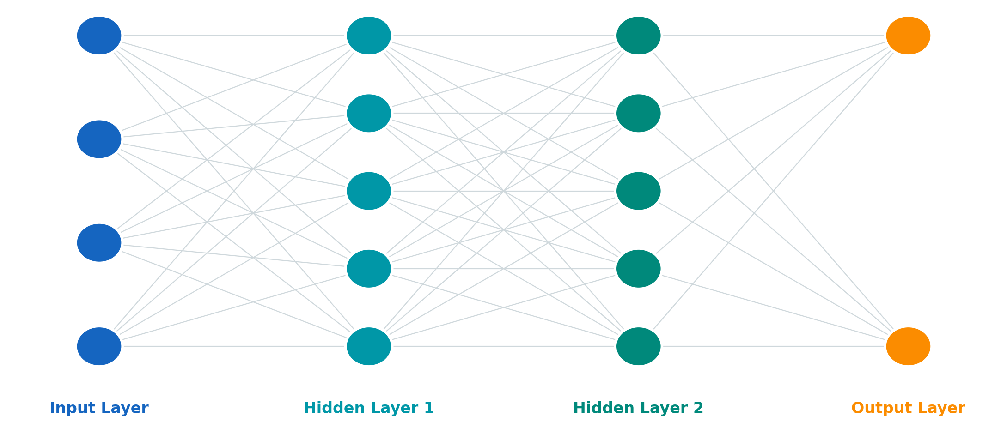
Figure 6. Simplified structure of a feed-forward neural network

Deep Neural Networks
A neural network that contains multiple hidden layers is described as a deep neural network, and it is this depth that enables the modelling of highly complex patterns (Lecun et al., 2015). Deep neural networks are responsible for many of the capabilities now regarded as characteristic of modern artificial intelligence, including speech recognition, medical diagnosis, image classification, and the control of autonomous systems.

Deep Learning Architectures
Deep learning encompasses several distinct network architectures, each designed for a particular kind of data. Three are especially important, and their typical workflows are compared in Figure 7.
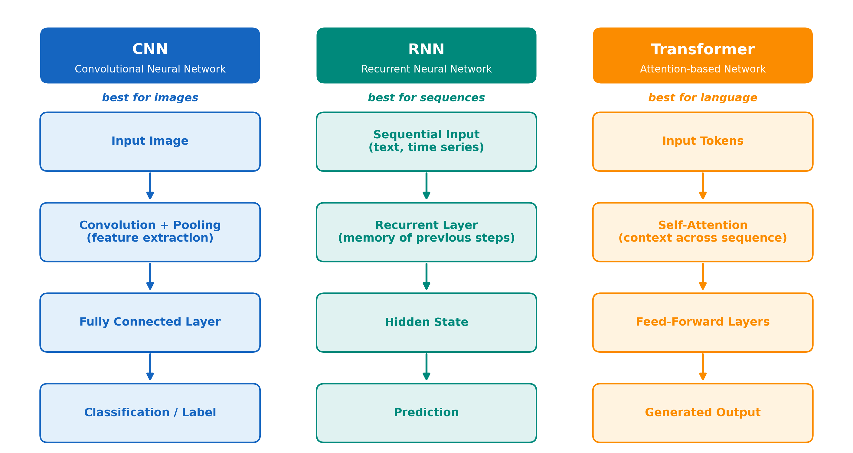
Figure 7. Workflows of the three principal deep learning architectures
Convolutional Neural Networks (CNNs) are designed primarily for the analysis of images. A CNN receives an image as input, extracts its visual features through successive convolution and pooling operations, and passes the result to fully connected layers that produce a final classification. In general use they support medical imaging and facial recognition, and in agriculture they are the leading method for plant-disease recognition and fruit classification from photographs (Kamilaris & Prenafeta-Boldú, 2018).
Recurrent Neural Networks (RNNs) are designed for sequential data, in which the order of the elements carries meaning, such as text or time series. An RNN processes the sequence step by step and retains a memory of previous steps, which enables it to model dependencies over time (Hochreiter & Schmidhuber, 1997). Typical applications include natural-language processing, time-series prediction, and educational analytics, in which learner activity is examined as it unfolds over the course of study.
Transformers are currently the most powerful architecture and form the basis of modern generative tools such as ChatGPT, Gemini, and Claude, as well as high-quality translation systems. Rather than processing a sequence strictly in order, a transformer uses a mechanism known as self-attention to weigh the relationships between all elements of the input simultaneously. This confers three notable advantages: the ability to understand context, to handle long sequences, and to generate fluent and coherent language (Russell & Norvig, 2020).

Applications in Education
In the classroom, machine learning and deep learning act as practical assistants for the teacher. They power personalised learning that adapts the content and pace of a lesson to each student, and learning analytics that flag struggling students, learning gaps, and drops in engagement early enough for the teacher to act. A model can predict which students are likely to fall behind from their performance data (Sarwat et al., 2022), and a camera-based system can read facial expressions during an online lesson to tell whether learners are following along or losing focus (Hu & Gao, 2025). AI also takes over much of the routine marking: it grades quizzes, gives instant feedback, and drafts practice questions, freeing the teacher to spend more time with individual learners.

Applications in Agriculture
On the farm, these techniques are already at work across the whole production cycle (Kamilaris & Prenafeta-Boldú, 2018; Liakos et al., 2018). The most established use is spotting disease: a convolutional neural network can recognise a sick plant from a photograph of its leaf with a high accuracy (Mohanty et al., 2016), and the same approach can map how far a disease has spread across an entire field (Sarwat et al., 2022). Machine learning also forecasts harvests from weather, soil, and past records, steers irrigation systems that give crops exactly the water they need, and drives precision-farming tools that treat each part of a field separately (Liakos et al., 2018). And AI no longer only analyses — it acts: autonomous robots now move through fields to weed and harvest, taking on the heaviest and most repetitive work (Bechar & Vigneault, 2016).

Learning Activities and Resources
Activity 1 — Classifying Educational Data
A school has collected data on student attendance, homework completion, and exam scores. Discuss:
• Which machine-learning approach (supervised, unsupervised, or reinforcement) would be appropriate, and why?
• Which features should be included?
• What predictions could the model produce, and how might they help teachers?
Activity 2 — Exploring Image Classification
Using a no-code tool such as Google Teachable Machine or Orange Data Mining, train a simple image classifier (for example, healthy vs. diseased leaves) and test it on new images. Note where it succeeds and where it fails.
Self-Assessment
1. Which type of learning uses labelled data?
a) Reinforcement b) Unsupervised c) Supervised d) Deep Learning
2. CNNs are primarily used for:
a) Text translation b) Image analysis c) Database management d) Spreadsheets
3. Deep Learning is a subset of:
a) Robotics b) Statistics c) Machine Learning d) Cloud Computing
Answers: 1-c, 2-b, 3-c
Reflection
• How can machine learning support teachers in their daily work?
• What ethical concerns arise when educational decisions are based on AI?
• What advantages does deep learning offer over traditional machine learning, and what are its costs?
Key Concepts:
Concept | Definition
Machine Learning | Learning patterns from data
Deep Learning | Neural network-based machine learning
Supervised Learning | Learning from labeled data
Unsupervised Learning | Discovering patterns in unlabeled data
Reinforcement Learning | Learning through rewards and penalties
CNN | Neural network for image processing
Transformer | Modern architecture for language and AI systems
Recommended Resources
• Google Machine Learning Crash Course: https://developers.google.com/machine-learning
• Elements of AI: https://www.elementsofai.com/
• TensorFlow Playground (interactive neural network): https://playground.tensorflow.org/
• Google Teachable Machine: https://teachablemachine.withgoogle.com/

References
Bechar, A., & Vigneault, C. (2016). Agricultural robots for field operations: Concepts and components. Biosystems Engineering, 149, 94–111. https://doi.org/10.1016/J.BIOSYSTEMSENG.2016.06.014
Celebi, M. E., & Aydin, K. (Eds.). (2016).Unsupervised learning algorithms (Vol. 1). Berlin: Springer International Publishing.
Christopher M. Bishop. (2006). Pattern Recognition and Machine Learning. Springer Nature Link. https://link.springer.com/in/book/9780387310732
Crespí, A., Mesquida, A. L., Monserrat, M., & Mas, A. (2025). Lifecycle models in machine learning development. Expert Systems, 42(4), e70029.
Goodfellow, I., Bengio, Y., Courville, A., & Bengio, Y. (2016). Deep learning.
Hochreiter, S., & Schmidhuber, J. (1997). Long Short-Term Memory. Neural Computation, 9(8), 1735–1780. https://doi.org/10.1162/NECO.1997.9.8.1735
Hu, X., & Gao, J. (2025). Facial expression recognition reveals students’ engagement in online class: Correlations with six engagement measurements. PLOS ONE, 20(10), e0334232. https://doi.org/10.1371/JOURNAL.PONE.0334232
Jordan, M. I., & Mitchell, T. M. (2015). Machine learning: Trends, perspectives, and prospects. Science, 349(6245), 255–260.
Kamilaris, A., & Prenafeta-Boldú, F. X. (2018). Deep learning in agriculture: A survey. Computers and Electronics in Agriculture, 147, 70–90. https://doi.org/10.1016/J.COMPAG.2018.02.016
Lecun, Y., Bengio, Y., & Hinton, G. (2015). Deep learning. Nature, 521(7553), 436–444.
Liakos, K. G., Busato, P., Moshou, D., Pearson, S., & Bochtis, D. (2018). Machine Learning in Agriculture: A Review. Sensors 2018, Vol. 18, Page 2674, 18(8), 2674. https://doi.org/10.3390/S18082674
Mitchell, T. M. (1999). Machine learning and data mining. ACM: Digital Library: Communications of the ACM. https://dl.acm.org/doi/fullHtml/10.1145/319382.319388
Mohanty, S. P., Hughes, D. P., & Salathé, M. (2016). Using deep learning for image-based plant disease detection. Frontiers in Plant Science, 7(September), 215232.
Morales, E. F., & Escalante, H. J. (2022). A brief introduction to supervised, unsupervised, and reinforcement learning. In Biosignal processing and classification using computational learning and intelligence (pp. 111-129). Academic Press.
Russell, S., & Norvig, P. (2020). Artificial Intelligence: A Modern Approach, 4/E.
Sarwat, S., Ullah, N., Sadiq, S., Saleem, R., Umer, M., Eshmawi, A. A., Mohamed, A., & Ashraf, I. (2022). Predicting Students’ Academic Performance with Conditional Generative Adversarial Network and Deep SVM. Sensors 2022, Vol. 22, Page 4834, 22(13), 4834.

Generative AI for Teachers
Generative artificial intelligence is the branch of AI that has brought the technology into everyday classrooms. Unlike the systems described earlier, which mainly analyze existing data, generative tools create something new — a paragraph of text, an image, or a set of quiz questions — in response to a simple written request. For a teacher, this turns the computer into a tireless assistant that can draft a lesson plan in seconds, rewrite a text for a younger class, or suggest exam questions on a given topic. What these tools produce is only ever a starting point, however, and their real value depends on how the request is written and on the teacher's judgement in reviewing the result.
Most of today's generative tools are built on large language models — deep neural networks, usually of the transformer type described in the previous section, that have been trained on vast quantities of text (Brown et al., 2020). During training, the model learns statistical patterns in language. Given a sequence of words, it predicts which words are most likely to follow. As seen Figure 8, when a teacher types a request, known as a prompt, the model uses these learned patterns to generate a response one piece at a time (Russell & Norvig, 2020). It is important to understand that the model does not "look up" answers or truly understand them; it produces the most plausible continuation of the text. This is why its output is best treated as a well-informed first draft that the teacher reviews and refines, rather than as a finished or guaranteed-correct product.
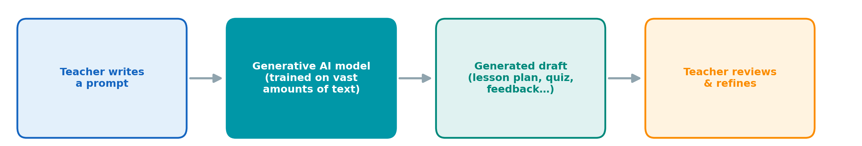
Figure 8. How a generative AI tool responds to a prompt
Several generative AI tools are now widely available, and although they differ in detail, they are used in much the same way. ChatGPT (OpenAI) is the best known and works mainly with text and images. Google Gemini is closely integrated with Google's search and productivity tools. Claude (Anthropic) is known for handling long documents and careful, structured writing. Microsoft Copilot is built into Office applications such as Word and PowerPoint, which makes it convenient for teachers who already work in that environment. For most teaching tasks the choice of tool matters less than the quality of the request made to it, and the skills described below transfer from one tool to another.

Applications in Teaching
Used thoughtfully, generative AI can save teachers a considerable amount of preparation time (Holmes & Miao, 2023; Kasneci et al., 2023). Its most common uses are the following.
Lesson planning: A teacher can ask for a structured lesson plan on a given topic, complete with objectives, activities, and timing — for example, a 40-minute lesson on soil types for agricultural students — and then adapt the draft to the class.
Quiz generation: The tools can quickly produce questions in a chosen format, such as multiple-choice or short-answer items on plant nutrition, together with an answer key.
Assessment creation: They can draft rubrics, worksheets, and exam questions at different difficulty levels, which the teacher then checks and adjusts.
Content adaptation: Existing material can be simplified for younger learners, translated into another language, or rewritten for a specific context — for instance, turning a general text on irrigation into a worked example for a local crop.
In agricultural education specifically, the same tools can translate complex technical information into clear teaching material — an approach already being trialed to give farmers simple, location-specific advice (Tzachor et al., 2023).

Writing Effective Prompts
The quality of a generative AI response depends heavily on the quality of the prompt: a vague request produces a vague answer, whereas a specific one produces something genuinely useful. A reliable way to write a good prompt is to include four elements — a role for the tool to adopt, the task to be done, the context it applies to, and the format of the desired output (Figure 9). For example, instead of asking "write a lesson about soil," a teacher might write: "Act as an agricultural VET teacher; create a 40-minute lesson plan on soil types and crop suitability for 15–16-year-old students; present it as a table with objectives, activities, and timing." The teacher can then continue the conversation, asking the tool to shorten, expand, or correct parts of the output until it fits the class.
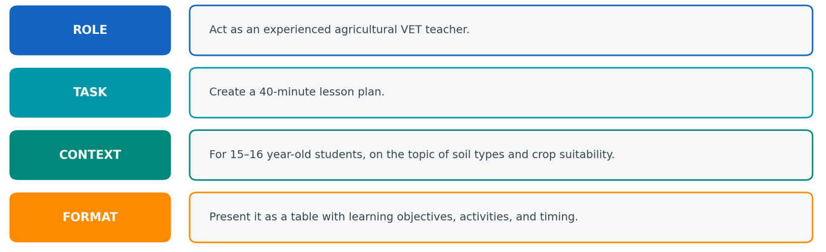
Figure 9. Anatomy of an effective prompt
Generative AI is a powerful assistant, but it has clear limitations that every teacher should keep in mind. Because these tools generate the most plausible text rather than verified facts, they can occasionally produce confident but incorrect statements, sometimes called hallucinations (Kasneci et al., 2023). They may also reflect biases present in their training data and raise questions of privacy and copyright. For these reasons, AI-generated material should always be checked by the teacher before it is used with students, and sensitive personal data should not be entered into public tools. These issues are examined in more detail in the next section, on ethical and responsible AI (Holmes & Miao, 2023).
Learning Activities and Resources
Workshop — Create a Lesson Plan with Generative AI
Choose a topic from your own subject area. Using a generative AI tool and the four-part prompt structure (role · task · context · format), generate a draft lesson plan. Then evaluate and improve it:
• Does it match your learning objectives and your students' level?
• Are the facts correct? Check them against a trusted source.
• Revise the prompt at least once to improve the result.
Share your final plan and describe what you changed and why.
Key Concepts
Concept | Definition
Generative AI | AI that creates new content such as text, images, or code
Large Language Model | A model trained on large text datasets to identify linguistic patterns and generate text
Prompt | The instruction or question a user gives to an AI model
Prompt Engineering  (role/task/context/format) | Writing clear prompts by defining the role, task, context, and output format
Draft-and-Refine | Generating a first draft with AI, then reviewing and improving it through further prompts
Human Oversight | The teacher checks, corrects, and takes responsibility for AI-generated content

References
Brown, T. B., Mann, B., Ryder, N., Subbiah, M., Kaplan, J., Dhariwal, P., Neelakantan, A., Shyam, P., Sastry, G., Askell, A., Agarwal, S., Herbert-Voss, A., Krueger, G., Henighan, T., Child, R., Ramesh, A., Ziegler, D. M., Wu, J., Winter, C., … Amodei, D. (2020). Language Models are Few-Shot Learners. Advances in Neural Information Processing Systems, 33, 1877–1901.
Holmes, W., & Miao, F. (2023). Guidance for generative AI in education and research. UNESCO.
Kasneci, E., Sessler, K., Küchemann, S., Bannert, M., Dementieva, D., Fischer, F., Gasser, U., Groh, G., Günnemann, S., Hüllermeier, E., Krusche, S., Kutyniok, G., Michaeli, T., Nerdel, C., Pfeffer, J., Poquet, O., Sailer, M., Schmidt, A., Seidel, T., … Kasneci, G. (2023). ChatGPT for good? On opportunities and challenges of large language models for education. Learning and Individual Differences, 103, 102274. https://doi.org/10.1016/J.LINDIF.2023.102274
Russell, S., & Norvig, P. (2020). Artificial Intelligence: A Modern Approach, 4/E.
Tzachor, A., Devare, M., Richards, C., Pypers, P., Ghosh, A., Koo, J., Johal, S., & King, B. (2023). Large language models and agricultural extension services. Nature Food 2023 4:11, 4(11), 941–948. https://doi.org/10.1038/s43016-023-00867-x

Ethical and Responsible AI
The tools introduced in the previous sections offer real benefits, but they also place a responsibility on the people who use them. For a teacher this responsibility is twofold: AI must be used ethically in one's own work, and the teacher sets an example for how students will use it. Society increasingly expects AI to be applied in a way that is fair, transparent, and respectful of people's rights (Jobin et al., 2019; UNESCO, 2021).
A few principles guide responsible use. The teacher, not the tool, remains in charge of every educational decision and is accountable for the final material. The use of AI should be transparent rather than hidden, and its output should be fair to all learners. Keeping these principles in mind, four practical risks deserve particular attention (European Commission, 2022).
Privacy: Online AI tools may store whatever is typed into them. A teacher should never enter students' personal data — names, grades, or health and behavioral information — into public AI tools and should prefer tools that clearly protect the data they receive (European Commission, 2022)
Copyright: Generative tools are trained on large amounts of existing work and can reproduce material that closely resembles it, while the ownership of AI-generated content is itself legally unsettled. A teacher should make sure that any distributed material does not infringe someone else's rights and should follow the institution's guidance on attribution.
Bias: Because models learn from data produced by people, they can absorb and repeat the unfairness in that data, favoring certain groups or reinforcing stereotypes (Mehrabi et al., 2022). In an agricultural course, for example, a tool might portray farming as an exclusively male occupation. AI output should therefore be reviewed for fairness before it is used.
Hallucinations: Generative tools produce the most plausible-sounding text rather than verified fact, so they sometimes state incorrect information with complete confidence (Kasneci et al., 2023). A model may invent statistics, a source, or a technical detail that looks entirely credible. Every factual claim in AI-generated material should be checked against a reliable source before it reaches students.

Evaluating AI-Generated Content
Putting these principles into practice, a teacher who receives a draft from an AI tool — a lesson plan, a quiz, or an explanation — should evaluate it before use rather than accept it at face value, as seen in Figure 10. A short set of questions makes this quick: is the content accurate, fair, respectful of privacy and copyright, and suitable for the class?
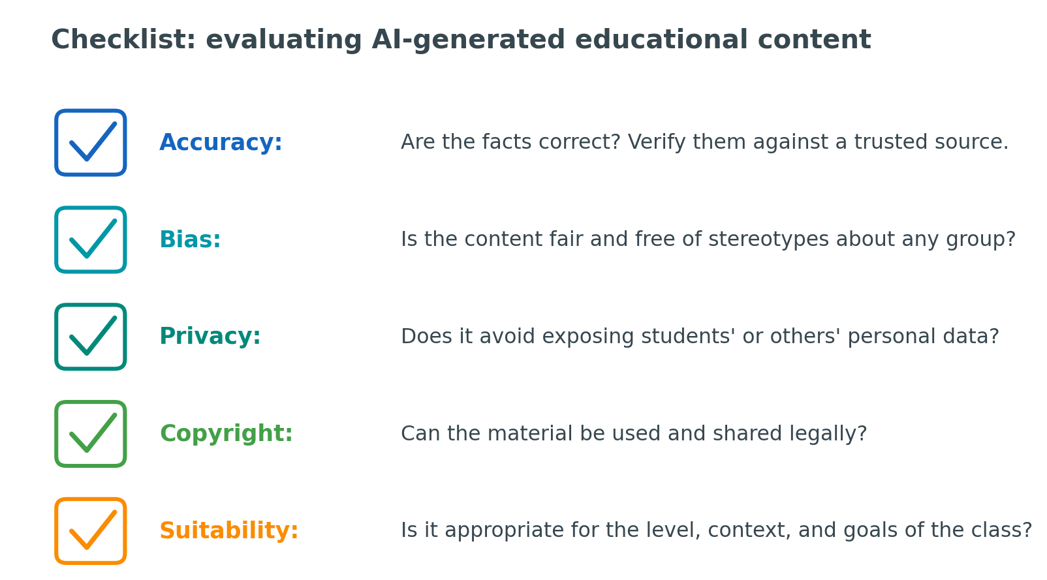
Figure 10. A checklist for evaluating AI-generated educational content
Working through these questions turns AI from a potential risk into a dependable assistant. It also models for students the critical, responsible use of technology that they will need in their own studies and future careers (Holmes & Miao, 2023).

Learning Activities and Resources
Case Study — Evaluating AI-Generated Content
Take a short piece of AI-generated teaching material (for example, a quiz or an explanation on a topic in your field). Apply the five-point checklist (accuracy, bias, privacy, copyright, suitability). Identify at least one problem and explain how you would correct it before using the material with students.
Reflection: Where is the line between using AI as a helpful assistant and relying on it too much? Who is responsible if AI-generated material misleads a student?
Key Concepts
Concept | Definition
AI Ethics | The principles guiding the responsible and fair use of AI
Privacy | Protecting students' and teachers' personal data from misuse
Copyright | Respecting ownership rights when using or generating content
Bias / Fairness | Ensuring AI does not produce unfair or discriminatory outcomes
Hallucination | When an AI confidently generates false or inaccurate information
Transparency | Being clear about when and how AI is used
Human Accountability | People, not AI, remain responsible for decisions and their consequences

References
European Commission. (2022). Ethical guidelines on the use of artificial intelligence (AI) and data in teaching and learning for educators. In Publications Office of the European Union.
Holmes, W., & Miao, F. (2023). Guidance for generative AI in education and research. UNESCO.
Jobin, A., Ienca, M., & Vayena, E. (2019). The global landscape of AI ethics guidelines. Nature Machine Intelligence 2019 1:9, 1(9), 389–399. https://doi.org/10.1038/s42256-019-0088-2
Kasneci, E., Sessler, K., Küchemann, S., Bannert, M., Dementieva, D., Fischer, F., Gasser, U., Groh, G., Günnemann, S., Hüllermeier, E., Krusche, S., Kutyniok, G., Michaeli, T., Nerdel, C., Pfeffer, J., Poquet, O., Sailer, M., Schmidt, A., Seidel, T., … Kasneci, G. (2023). ChatGPT for good? On opportunities and challenges of large language models for education. Learning and Individual Differences, 103, 102274. https://doi.org/10.1016/J.LINDIF.2023.102274
Kasneci, E., Sessler, K., Küchemann, S., Bannert, M., Dementieva, D., Fischer, F., Gasser, U., Groh, G., Günnemann, S., Hüllermeier, E., Krusche, S., Kutyniok, G., Michaeli, T., Nerdel, C., Pfeffer, J., Poquet, O., Sailer, M., Schmidt, A., Seidel, T., … Kasneci, G. (2023). ChatGPT for good? On opportunities and challenges of large language models for education. Learning and Individual Differences, 103, 102274. https://doi.org/10.1016/J.LINDIF.2023.102274
Mehrabi, N., Morstatter, F., Saxena, N., Lerman, K., & Galstyan, A. (2022). A Survey on Bias and Fairness in Machine Learning. ACM Computing Surveys, 54(6).
UNESCO. (2021). Recommendation on the ethics of artificial intelligence. UNESCO

