Data Science and Data Literacy for Educators
Author: Assoc. Prof. Emre Dandıl

Purpose
To equip teachers with the ability to understand, analyze and use data for educational and professional decision-making.

Learning Outcomes
Participants will be able to:
- Understand the data lifecycle.
- Collect and organize datasets.
- Perform basic data analysis.
- Create meaningful visualizations.
- Apply data-driven decision making.

Table of Contents
1. Fundamentals of Data Science 4
1.1. Types of Data 4
1.2. Big Data Concepts 5
1.3. Data-Driven Decision Making 6
2. Data Collection and Management 7
2.1. Data Sources 7
2.2. Open Data Platforms 8
2.3. Data Quality 9
2.4. Data Cleaning 9
3. Data Analysis and Visualization 11
3.1. Descriptive Statistics 11
3.2. Data Interpretation 13
3.3. Dashboards 14
3.4. Infographics 15
3.5. Data Analysis and Visualization Tools 16
4. Data Literacy in Education 19
4.1. Learning Analytics 19
4.2. Student Performance Data 19
4.3. Educational Dashboards 20

Fundamentals of Data Science
The amount of data produced today has reached a scale never seen before. Every sensor reading, every field record, every weather report, and every market price is a piece of data. But data on its own has no meaning; in its raw form it is little more than numbers and text. This is where data science comes in: the discipline that turns scattered, raw data into meaningful knowledge that can guide a decision (Provost & Fawcett, 2013).
Data science brings together three areas — statistics, computer science, and knowledge of the field being studied — and its value lies in combining them (Donoho, 2017). In agriculture this can mean linking climate data to crop yield or connecting soil conditions to the spread of a particular disease.
The work of turning data into a decision usually unfolds as a connected sequence of stages rather than a single leap from data to answer, following the cycle shown in Figure 1 (Wickham & Grolemund, 2017). It begins with a clear question — for example, why the yield of a particular field has fallen from one season to the next. The data needed to answer it, such as soil measurements, irrigation records, and weather readings, is then collected and cleaned, since errors and missing values must be corrected first. This cleaning stage often takes the most time, because a good result depends on good data. The clean data is then analyzed to find patterns, and the results are visualized as charts so that they are easy to grasp. Finally, the insight guides a decision — adjusting irrigation, revising a fertilizer plan, or choosing a different variety for the next season. The stages form a cycle rather than a straight line, because each answer tends to raise new questions.
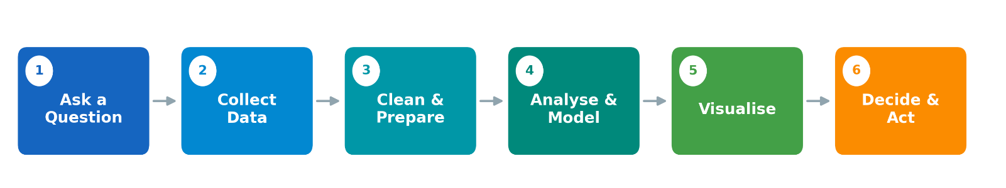Figure 1. The data science workflow, from question to decision.

Types of Data
Not all data is stored or analyzed in the same way, and identifying the type of data is the first step in handling it correctly. Data is commonly divided into three categories according to how organized it is, as shown in Figure 2 (Gandomi & Haider, 2015).
Structured Data: Highly organized information that fits neatly into rows and columns, such as the contents of a spreadsheet or a database. Field records, yield tables, and numerical sensor readings such as temperature or soil moisture are typical examples. Because its format is fixed and predictable, structured data is the easiest to search and analyze.
Semi-structured Data: Information that does not fit a rigid table but still carries tags or markers that give it some organization. Files in JSON or XML format, e-mails, and system logs belong to this group. It offers more flexibility than structured data while remaining machine-readable.
Unstructured Data: Information with no predefined format, which makes up the large majority of the data generated today. Text documents, photographs, audio recordings, and video all fall into this category — a field technician's written note or a photograph of a diseased crop leaf, for example. This data is rich in information but far harder to process.
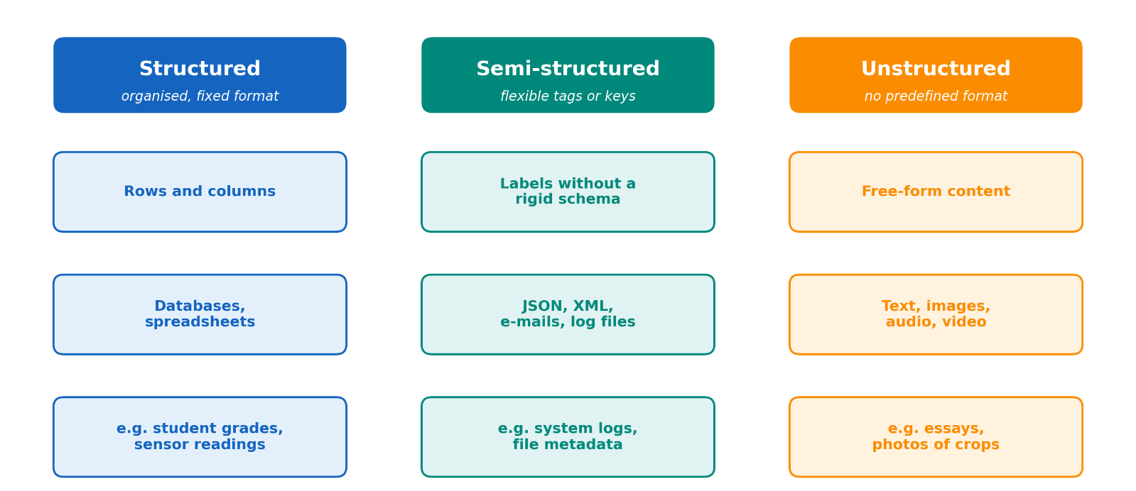
Figure 2. The three main types of data: structured, semi-structured, and unstructured.

Big Data Concepts
Some datasets are small enough to open in a single spreadsheet. Others are not. A weather service collecting readings from thousands of stations every minute, or a satellite programme storing images of farmland across an entire country, produces data on a scale that ordinary tools simply cannot handle. This is what the term big data describes: data that is too large, too fast, or too varied to be managed in the usual way (De Mauro et al., 2016).
To make this idea concrete, big data is usually described through five properties, known as the five V's and shown in Figure 3. The first three were introduced to capture the practical challenges of managing data (Laney, 2001), and two more were later added to reflect questions of trust and purpose (Gandomi & Haider, 2015).
Volume: The sheer quantity of data, now routinely measured in terabytes or even petabytes.
Velocity: The speed at which data is generated and must be processed, sometimes in real time, such as a continuous stream of readings from field sensors.
Variety: The wide range of data types and sources, from structured database records to unstructured images and text.
Veracity: The quality and trustworthiness of the data, since inaccurate or biased data leads to misleading conclusions.
Value: The ultimate purpose, because data is only worthwhile if it can be turned into insight that supports a better decision.
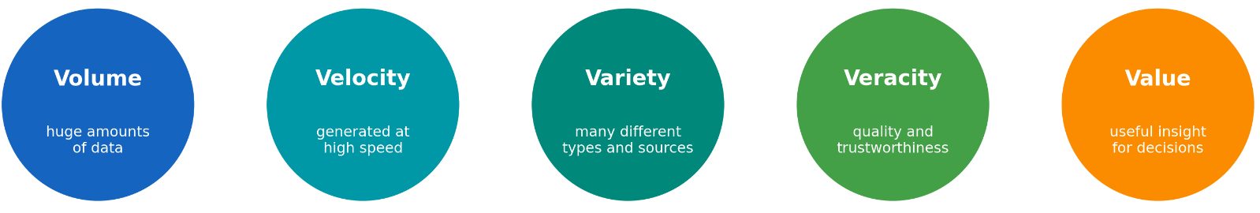
Figure 3. The five V's that characterize big data.

Data-Driven Decision Making
Data-driven decision making is the practice of basing a choice on what the data actually shows rather than on intuition or habit alone (Provost & Fawcett, 2013). The idea is simple: instead of deciding first and looking for evidence afterwards, the decision is built on the evidence from the start. Whether to irrigate a field is settled from soil-moisture readings and the weather forecast; which variety to plant is settled from several seasons of yield records; when to harvest is settled from market prices together with climate data. In each case the data does not make the decision by itself, but it frames the choice and narrows it down.
What makes this approach powerful is that it turns decision making into a repeating loop rather than a one-off guess. Conditions are measured, the data is analyzed, an action is taken, and its result becomes new data that feeds the next decision. As more of what happens on and around the farm is recorded, this loop can run faster and more precisely, allowing problems to be caught earlier and resources to be used more efficiently (Wolfert et al., 2017) and such data-driven methods are increasingly central to precision agriculture (Ahanou et al., 2026).
Two conditions decide whether the approach actually helps. First, a decision can never be better than the data behind it, so unreliable or biased data leads to unreliable decisions — the data must be checked before it is trusted. Second, the numbers show what is happening, but experience and knowledge of local conditions are still needed to understand why and to judge what to do next; evidence and judgement work best together. When good data is combined with sound judgement, and gathered responsibly with respect for privacy, a data-driven approach makes it possible to act earlier, waste less, and improve steadily over time.

Learning Activities and Resources
Discussion: Where does data already shape decisions around you?
In small groups, list three decisions on a farm or in a classroom that already rely on data, and identify the type of data each one uses (structured, semi-structured or unstructured).
Reflection. A trainer gathers soil-moisture readings, weather data and several seasons of yield records for one field.
• What question could this combined data help to answer?
• Which of the five V’s of big data would be hardest to guarantee here?
• What could go wrong if the data were biased or incomplete?
Key Concepts
Concept | Definition
Data science | Turning raw data into knowledge for making decisions
Data types | Structured, semi-structured and unstructured data
Big data (five V’s) | Volume, velocity, variety, veracity, value
Data-driven decisions | Basing choices on evidence rather than habit

Recommended Resources
• Our World in Data (open data and charts): https://ourworldindata.org
• Elements of AI (free introductory course): https://www.elementsofai.com

References
Ahanou, Z., Mrabti, F., & Dhassi, Y. (2026). Big data analytics in precision agriculture: An automated systematic literature review. Computers and Electronics in Agriculture, 243, 111401. https://doi.org/10.1016/J.COMPAG.2025.111401
De Mauro, A., Greco, M., & Grimaldi, M. (2016). A formal definition of Big Data based on its essential features. Library Review, 65(3), 122–135. https://doi.org/10.1108/LR-06-2015-0061
Donoho, D. (2017). 50 Years of Data Science. Journal of Computational and Graphical Statistics, 26(4), 745–766. https://doi.org/10.1080/10618600.2017.1384734
Gandomi, A., & Haider, M. (2015). Beyond the hype: Big data concepts, methods, and analytics. International Journal of Information Management, 35(2), 137–144. https://doi.org/10.1016/J.IJINFOMGT.2014.10.007
Laney, D. (2001). 3D data management: Controlling data volume, velocity and variety. META Group Research Note.
Provost, F., & Fawcett, T. (2013). Data Science and its Relationship to Big Data and Data-Driven Decision Making. Big Data, 1(1), 51–59.
Wickham, H., & Grolemund, G. (2017). R for data science.
Wolfert, S., Ge, L., Verdouw, C., & Bogaardt, M. J. (2017). Big Data in Smart Farming – A review. Agricultural Systems, 153, 69–80. https://doi.org/10.1016/J.AGSY.2017.01.023

Data Collection and Management
The reliability of any analytical result is bounded by the quality of the data on which it rests. Data obtained without a defined procedure, or retained without adequate structure, cannot be remedied by subsequent analysis, and errors introduced at this stage tend to propagate through every step that follows. Sound data management is therefore a precondition for meaningful analysis rather than a preliminary formality.

Data Sources
Data is conventionally classified according to its origin, in Figure 3, a distinction that carries practical consequences for cost, control, and reliability. Primary Data is collected first-hand for a defined purpose — for instance, readings obtained from a soil sensor, measurements recorded during a field trial, or responses gathered through a survey. Because it is designed around the research question, it offers precision and control, but its collection demands time and resources. Secondary Data, by contrast, is drawn from information collected previously by others and repurposed for a new question, such as national yield statistics, published research datasets, or long-term meteorological archives. It is typically less costly and wider in coverage, yet it may not align exactly with the question, and its provenance requires verification before use.
The diversity of sources available in agriculture has increased markedly with the advance of digital technologies (Shamshiri et al., 2024; Wolfert et al., 2017). Field sensors and Internet-of-Things devices record soil moisture, temperature, and humidity; satellites and unmanned aerial vehicles supply remote-sensing imagery at regional scale; agricultural machinery logs its own operation; and automated weather stations produce continuous measurement, while direct observation continues to record what instruments cannot. Figure 1 groups representative examples of these sources under the two categories. In practice, a single question is often best addressed by integrating several of them — combining, for instance, sensor readings with satellite imagery and historical yield statistics — because each source captures only part of the system under study.
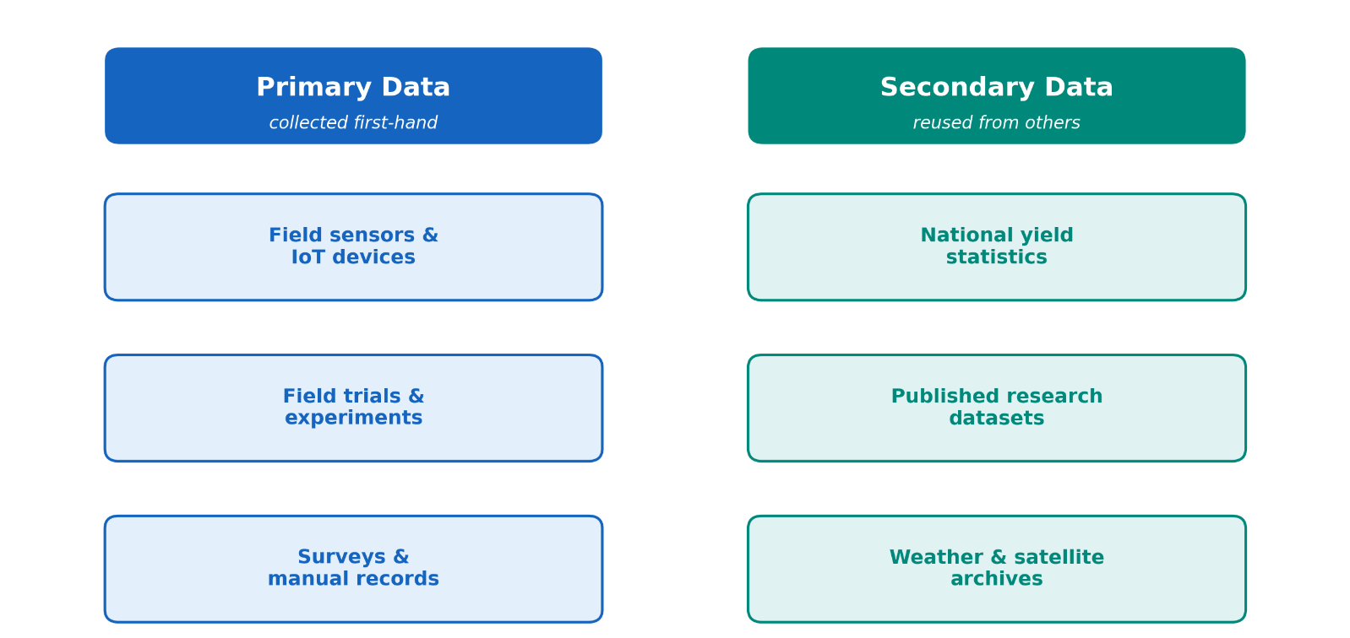
Figure 3. Common sources of agricultural data are grouped as primary and secondary.

Open Data Platforms
A great deal of data today is published as open data — data that anyone can access, use, and share freely, usually as long as the source is credited. Open data gives access to large, well-kept datasets at no cost, so anyone working with data is not limited to what they can collect on their own. Many such platforms exist, and several are especially useful in agriculture: FAOSTAT offers global farming and food statistics from the Food and Agriculture Organization; Copernicus provides Earth-observation and climate data from the European Union; NASA POWER shares climate and solar data suited to agriculture; the National Agricultural Statistics Service of the United States Department of Agriculture publishes national farm statistics; and World Bank Open Data provides economic and development figures. More general sites such as Kaggle also host ready-to-use datasets shared by a wide community.
Open data is only helpful if it is easy to find and work with. The FAIR principles sum this up: data should be Findable, Accessible, Interoperable, and Reusable (Wilkinson et al., 2016). Before using any dataset, two things are worth checking — its license, which says how the data may be used, and its source, meaning who collected it, when, and how, because a dataset is only as trustworthy as where it came from.

Data Quality
Not all data can be trusted to the same degree, so checking its quality is a necessary step before any analysis. Quality is not a single thing but a mix of a few well-known features (Ridzuan & Zainon, 2024; Wang & Strong, 1996), shown in Figure 4. Accuracy is whether the recorded values match reality — for example, whether a measurement agrees with a careful check. Completeness is whether any important values are missing, such as gaps in a record. Consistency is whether the data agrees with itself, without the same thing written in two different ways or units. Timeliness is whether the data is recent enough for the decision it is meant to support.
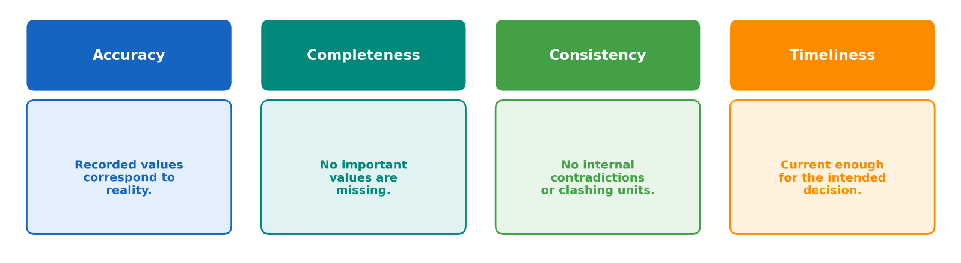
Figure 4. The four core dimensions of data quality.
Poor quality rarely announces itself. A faulty sensor, a mistyped entry, or two datasets that label the same thing differently can all pass unnoticed until they quietly distort a result. For this reason, quality is best checked on purpose rather than taken for granted: it helps to look at a sample of the data by hand, compare it against a source already known to be reliable, and watch for values that fall outside a sensible range. A few simple checks of this kind, done early, catch most of the problems that would otherwise cause trouble later.

Data Cleaning
Data almost never arrives ready to use. Real datasets usually contain mistakes, gaps, and inconsistencies, and these must be dealt with before any analysis can begin. This step is called data cleaning, and it is often the most time-consuming part of the whole process (Lomet et al., n.d.). The main tasks come up again and again and are shown in Figure 5: handling missing values, by filling them in sensibly or setting the affected records aside; removing duplicates, so that the same record is not counted twice; correcting errors and outliers, such as an impossible value produced by a broken sensor; and standardizing formats, so that dates, units, and names all follow one style throughout.
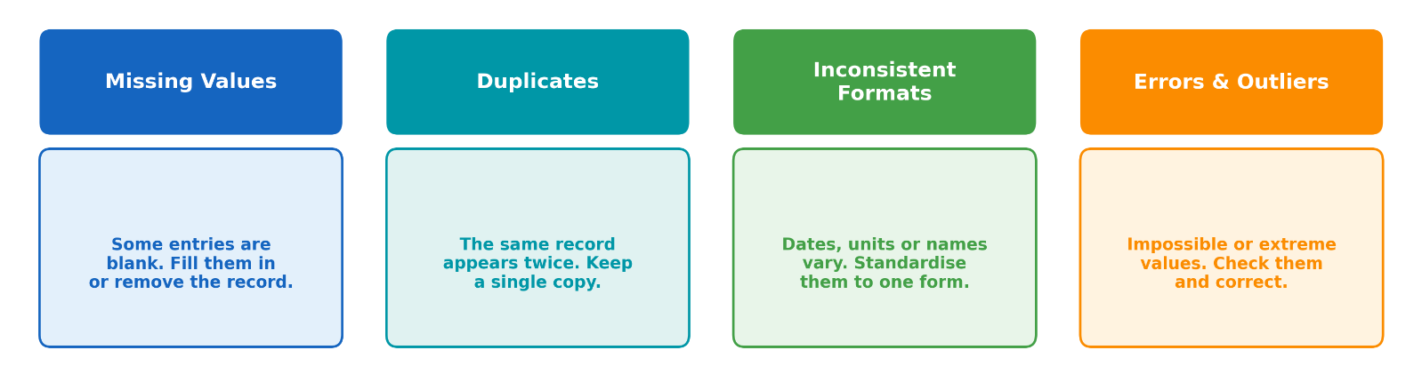
Figure 5. Common data cleaning problems and their remedies.
The objective of these operations is a tidy dataset, in which each row represents a single observation and each column a single variable (Wickham, 2014). A dataset organized in this way provides a consistent and reliable foundation for the analytical and visualization stages that follow.
Learning Activities and Resources
Discussion: Where does your data come from?
List the data sources available to you and sort them into primary and secondary data. Which are open, and which would need permission to use?
Activity – Exploring open agricultural datasets. Choose one dataset from an open platform such as FAOSTAT or Copernicus.
• Identify its type and whether it is primary or secondary data.
• Assess it against the four quality dimensions: accuracy, completeness, consistency and timeliness.
• List the cleaning steps it would need, and record its license and source.
Key Concepts
Concept | Definition
Primary vs. secondary data | Collected first-hand vs. reused from others
Open data & FAIR | Freely reusable; findable, accessible, interoperable, reusable
Data quality | Accuracy, completeness, consistency, timeliness
Data cleaning | Fixing missing values, duplicates, errors and formats

Recommended Resources
• FAO – FAOSTAT: https://www.fao.org/faostat
• Copernicus (EU Earth observation): https://www.copernicus.eu
• Kaggle Datasets: https://www.kaggle.com/datasets
• World Bank Open Data: https://data.worldbank.org

References
Lomet, D. B., Gravano, L., Levy, A., & Weikum, G. (n.d.). Data cleaning: Problems and current approaches.
Ridzuan, F., & Zainon, W. M. N. W. (2024). A Review on Data Quality Dimensions for Big Data. Procedia Computer Science, 234, 341–348. https://doi.org/10.1016/J.PROCS.2024.03.008
Shamshiri, R. R., Sturm, B., Weltzien, C., Fulton, J., Khosla, R., Schirrmann, M., Raut, S., Basavegowda, D. H., Yamin, M., & Hameed, I. A. (2024). Digitalization of agriculture for sustainable crop production: a use-case review. Frontiers in Environmental Science, 12, 1375193.
Wang, R. Y., & Strong, D. M. (1996). Beyond Accuracy: What Data Quality Means to Data Consumers. Journal of Management Information Systems, 12(4), 5–34. https://doi.org/10.1080/07421222.1996.11518099
Wickham, H. (2014). Tidy Data. Journal of Statistical Software, 59(10), 1–23. https://doi.org/10.18637/JSS.V059.I10
Wickham, H., & Grolemund, G. (2017). R for data science.
Wilkinson, M. D., Dumontier, M., Aalbersberg, Ij. J., Appleton, G., Axton, M., Baak, A., Blomberg, N., Boiten, J. W., da Silva Santos, L. B., Bourne, P. E., Bouwman, J., Brookes, A. J., Clark, T., Crosas, M., Dillo, I., Dumon, O., Edmunds, S., Evelo, C. T., Finkers, R., … Mons, B. (2016). The FAIR Guiding Principles for scientific data management and stewardship: Comment. Scientific Data, 3, 160018. https://doi.org/10.1038/SDATA.2016.18
Wolfert, S., Ge, L., Verdouw, C., & Bogaardt, M. J. (2017). Big Data in Smart Farming – A review. Agricultural Systems, 153, 69–80. https://doi.org/10.1016/J.AGSY.2017.01.023

Data Analysis and Visualization
Data analysis is the process of examining, summarising and interpreting collected data to identify meaningful patterns and support decision-making. Raw data may contain large numbers of observations, different variables, missing values and measurement errors. Analysis transforms these observations into information that educators, agricultural trainers and decision-makers can understand and use (Provost & Fawcett, 2013).
Data visualisation is closely connected to data analysis. It refers to the graphical representation of information through charts, tables, maps and dashboards. Effective visualisations make comparisons, trends and unusual observations easier to recognise. However, a visualisation should not merely be attractive; it must represent the data accurately, use an appropriate format and communicate a clear message without misleading the reader (Cairo, 2016; Ware, 2021).
In agricultural education, data analysis and visualisation can be used to examine crop yields, rainfall, soil conditions, irrigation, animal production and market prices. These methods support the interpretation of complex agricultural data and contribute to evidence-based decision-making in smart farming and sustainable crop production (Shamshiri et al., 2024; Wolfert et al., 2017).

Descriptive Statistics
Descriptive statistics consist of methods used to organize and summaries the main characteristics of a dataset in Table 1. They allow users to understand the center, spread and general distribution of values before carrying out more advanced analysis (Field, 2024).
Table 1. Common Descriptive Statistics
Statistical measure | Definition | Agricultural example | Educational example
Count | The total number of observations in a dataset | Number of farms included in a survey | Number of students in a class
Mean | The sum of all values divided by the number of observations | Average wheat yield per hectare | Average examination score
Median | The middle value after the observations are arranged in order | Median farm income | Median student score
Mode | The value or category that occurs most frequently | Most commonly cultivated crop | Most frequently selected answer
Minimum | The smallest observed value | Lowest recorded temperature | Lowest examination score
Maximum | The largest observed value | Highest crop yield | Highest examination score
Range | The difference between the maximum and minimum values | Difference between the highest and lowest rainfall records | Difference between the highest and lowest scores
Standard deviation | A measure of how widely values are distributed around the mean | Variation in crop yield among farms | Variation in student performance
Percentage | A proportion expressed as a value out of 100 | Percentage of irrigated farmland | Percentage of students who passed

Descriptive measures should be interpreted together rather than separately. The mean provides a useful summary of the centre of a dataset, but it may be affected by unusually high or low observations. The median may therefore offer a more representative value in datasets containing extreme observations. Measures such as the range and standard deviation complement these central measures by showing how widely the observations are distributed (Field, 2024). Two datasets may have the same mean while showing considerably different levels of variation, as illustrated in Figure 6.
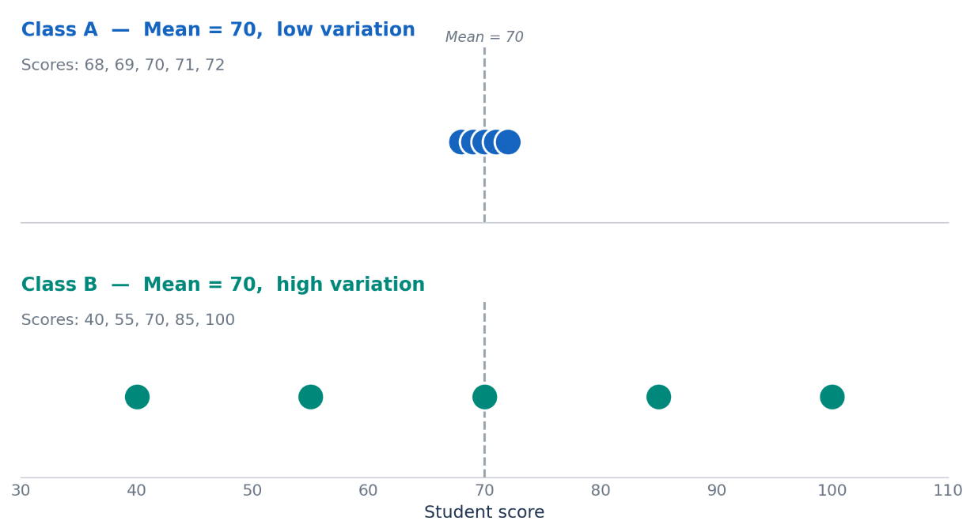
Figure 6. Two datasets with the same mean but different levels of variation

Data Interpretation
Data interpretation is the process of examining analytical results and explaining what they mean in relation to a specific question, context or decision (Table 2). It involves identifying relevant patterns, comparisons and unusual observations while also considering the quality and limitations of the underlying data. Interpretation therefore goes beyond reporting numerical values and requires the analyst to connect the evidence with the problem being investigated (Agresti et al., 2018).In agricultural education, data interpretation may be used to examine changes in crop yield, rainfall, temperature, soil conditions or irrigation use.
Table 2. Main elements of data interpretation
Element | Meaning | Example
Trend | A general direction of change over time | Crop yield gradually increasing over six years
Comparison | Examining differences between categories or periods | Comparing wheat and barley production
Distribution | Examining how values are spread | Distribution of student examination scores
Outlier | An observation that is unusually different from others | An exceptionally low yield in one year
Correlation | A statistical relationship between two variables | Rainfall increasing together with crop yield
Missing value | Information that was not recorded or is unavailable | A sensor failing to record soil moisture
Uncertainty | The degree of confidence that can be placed in a result | Yield estimates based on a small sample

Interpretation should be based on evidence rather than assumptions. A visible pattern may suggest a possible explanation, but it does not automatically establish the cause of that pattern. For example, an increase in crop yield may occur alongside higher rainfall, but other factors such as seed quality, fertiliser use, soil properties or farming practices may also influence the result. Relationships between variables should therefore be interpreted carefully, particularly because correlation alone does not demonstrate causation (Agresti et al., 2018).
The reliability of an interpretation also depends on data quality. Missing observations, measurement errors, inconsistent units and unrepresentative samples can alter analytical results and lead to misleading conclusions. Before interpreting a pattern, the analyst should consider how the data was collected, whether the observations are complete and whether the dataset adequately represents the situation under investigation (Ridzuan & Zainon, 2024; Wang & Strong, 1996).
A trend may exist even when individual observations fluctuate. Similarly, an unusual value may represent a genuine event rather than an error. The wheat-yield data in Figure 7 illustrates a general upward trend together with one unusually low observation.
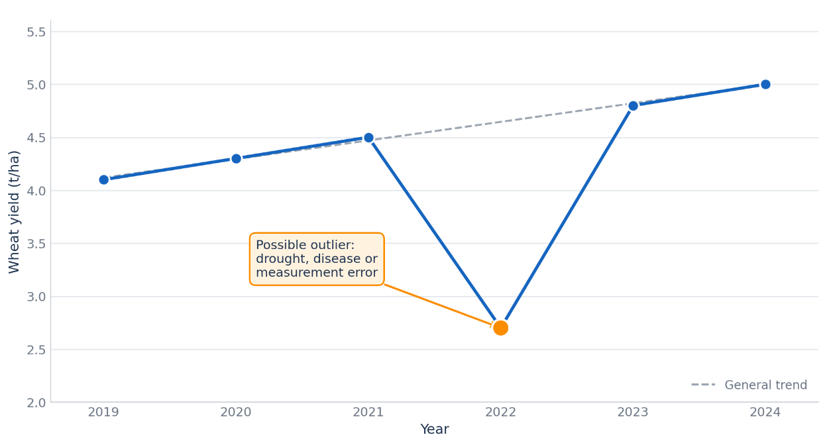
Figure 7. Identifying a trend and an outlier in wheat-yield data

Dashboards
A dashboard is a visual interface that brings together selected indicators, charts, tables and maps in a single display. Its purpose is to help users monitor conditions, compare results and support decisions more efficiently. A well-designed dashboard presents complex information in a clear and concise form (Few, 2013; Sarikaya et al., 2019). In agriculture, dashboards can combine data such as rainfall, temperature, soil moisture, irrigation use, crop yield and production costs. In education, they may present attendance, assessment results, assignment completion and learner participation. The content of a dashboard should always reflect the needs of its intended users (Shamshiri et al., 2024; Wolfert et al., 2017).
The most important values are often shown as key performance indicators, while charts provide additional context by displaying trends, comparisons or relationships. Visual simplicity is essential. Too many colours, labels or charts can make the dashboard difficult to understand. Important indicators should therefore be placed prominently, related information should be grouped together and measurement units should be used consistently (Few, 2013; Knaflic, 2015).
Dashboards should also provide a basis for comparison. A value becomes more meaningful when it is compared with a target, a previous season or a regional average. Interactive dashboards may allow users to filter information by year, region or crop type, but these functions should remain simple and easy to use (Sarikaya et al., 2019). Figure 8 presents an example agricultural dashboard that combines summary indicators with rainfall, crop-yield and irrigation visualizations.
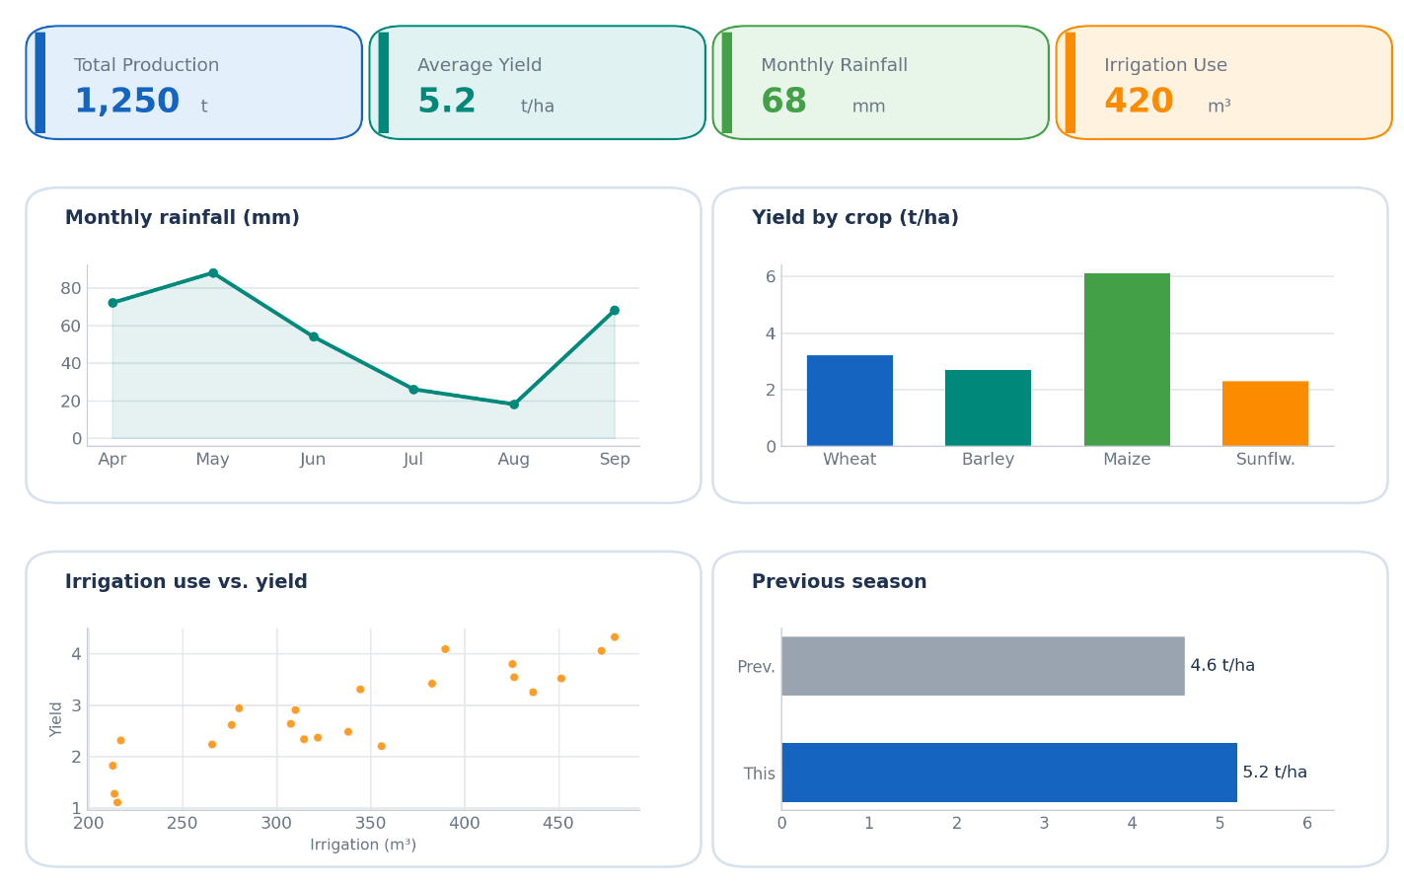
Figure 8. Example agricultural monitoring dashboard

Infographics
An infographic is a visual communication format that combines data, charts, icons and short explanatory text in order to present information clearly and effectively. Its purpose is not to display every detail in a dataset, but to communicate the most important message in a form that is easy to understand (Krum, 2013).
In agricultural education, infographics can be used to summarize water use, crop production, soil conditions, sustainable farming practices or seasonal agricultural activities. In educational settings, they can also present survey results, classroom findings or project outcomes. Compared with dashboards, infographics usually communicate a fixed message rather than support continuous monitoring.
A good infographic should focus on one central idea, use a logical reading order and include only the most relevant information. Titles, labels, values and units should be clear, while charts and icons should support the message rather than distract from it. The data source should also be shown clearly so that readers can judge the reliability of the information (Cairo, 2016). Figure 9 presents an illustrative infographic example related to agricultural water use and irrigation efficiency.
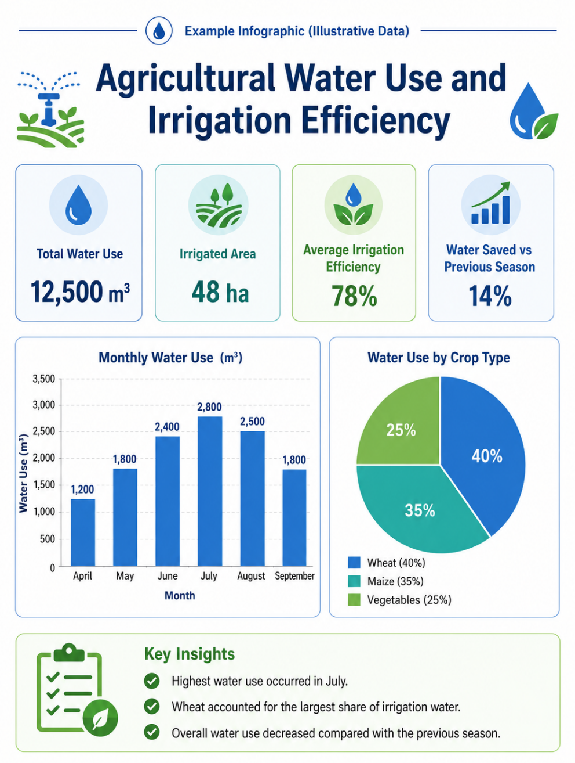
Figure 9. Illustrative infographic example: Agricultural Water Use and Irrigation Efficiency

Data Analysis and Visualization Tools
A variety of digital tools can be used for data analysis and visualization. The choice of tool depends on the type of data, the complexity of the analysis, the intended output and the digital competence of the user. Some tools are more suitable for introductory spreadsheet-based analysis, while others support interactive dashboards, advanced visualization or reproducible data analysis (Table 3).
Spreadsheet tools such as Microsoft Excel and Google Sheets are widely used for organizing data, applying formulas, calculating descriptive statistics and creating basic charts. Business-intelligence tools such as Microsoft Power BI and Tableau are more suitable for integrating multiple data sources and building interactive dashboards. Programming environments such as Python provide greater flexibility for statistical analysis, automation and advanced visualization.
Table 3. Comparison of data analysis and visualization tools
Tool | Main uses | Advantages | Limitations
Microsoft Excel | Calculations, descriptive statistics, pivot tables and charts | Widely used and suitable for introductory analysis | Large or complex datasets may become difficult to manage
Google Sheets | Collaborative spreadsheets, calculations and charts | Supports real-time online collaboration | Advanced modelling and dashboard functions are more limited
Microsoft Power BI | Combining datasets and creating interactive dashboards | Interactive filters, multiple data sources and strong dashboard features | Requires additional training
Tableau | Interactive data exploration and visualization | Strong visual exploration and presentation | Full functionality may require a paid license
Python | Statistical analysis, automation and advanced visualization | Flexible and suitable for reproducible analysis | Requires programming knowledge
The selection of a tool should be guided by the learning objective rather than by the number of available features. Excel or Google Sheets may be appropriate when participants are learning basic calculations, descriptive statistics and chart creation. Power BI and Tableau are more suitable when the aim is to create interactive dashboards or combine multiple datasets. Python may be preferred in more advanced contexts where automation, reproducibility and flexible analysis are required.
Regardless of the software used, effective data analysis depends on the quality of the data, the appropriateness of the analytical method and the accuracy of interpretation. A sophisticated tool cannot compensate for incomplete, inaccurate or poorly organized data (Wang & Strong, 1996).
Learning Activities and Resources
Discussion: Which chart fits which question?
For each case – comparing crop yields, following rainfall across a season, and showing a crop’s share of a field – decide which chart type is most suitable, and explain why.
Reflection. A bar chart uses a vertical axis that starts at 90 instead of 0, making a small difference look large.
• Why can a truncated axis mislead the reader?
• How would the same data look on an axis starting at zero?
Workshop – Creating an agricultural data dashboard. Import an open dataset into Excel or Google Sheets, produce three basic charts, arrange them on one sheet, and write two or three sentences interpreting what they show.
Key Concepts
Concept | Definition
Descriptive statistics | Mean, median, range and standard deviation
Correlation vs. causation | Moving together is not the same as one causing the other
Dashboard | Several charts on one screen for monitoring
Infographic | Charts, icons and text conveying one main message

Recommended Resources
• From Data to Viz (chart chooser): https://www.data-to-viz.com
• Datawrapper (free charts and maps): https://www.datawrapper.de
• Flourish (data visualisation and storytelling): https://flourish.studio

References
Agresti, A., Franklin, C., & Klingenberg, B. (2018). Statistics: The Art and Science of Learning from Data, 4/E.
Cairo, Alberto. (2016). The truthful art: data, charts, and maps for communication.
Few, S. (2013). Information Dashboard Design: Displaying Data for At-a-Glance Monitoring, 2/E.
Field, A. (2024). Discovering Statistics Using IBM SPSS Statistics.
Knaflic, C. N. (2015). Storytelling with data: A data visualization guide for business professionals. Storytelling with Data: A Data Visualization Guide for Business Professionals, 1–267. https://doi.org/10.1002/9781119055259
Krum, R. (2013). Cool Infographics: Effective Communication with Data Visualization and Design.
Provost, F., & Fawcett, T. (2013). Data Science and its Relationship to Big Data and Data-Driven Decision Making. Big Data, 1(1), 51–59.
Ridzuan, F., & Zainon, W. M. N. W. (2024). A Review on Data Quality Dimensions for Big Data. Procedia Computer Science, 234, 341–348. https://doi.org/10.1016/J.PROCS.2024.03.008
Sarikaya, A., Correll, M., Bartram, L., Tory, M., & Fisher, D. (2019). What do we talk about when we talk about dashboards? IEEE Transactions on Visualization and Computer Graphics, 25(1), 682–692. https://doi.org/10.1109/TVCG.2018.2864903
Shamshiri, R. R., Sturm, B., Weltzien, C., Fulton, J., Khosla, R., Schirrmann, M., Raut, S., Basavegowda, D. H., Yamin, M., & Hameed, I. A. (2024). Digitalization of agriculture for sustainable crop production: a use-case review. Frontiers in Environmental Science, 12, 1375193.
Wang, R. Y., & Strong, D. M. (1996). Beyond Accuracy: What Data Quality Means to Data Consumers. Journal of Management Information Systems, 12(4), 5–34. https://doi.org/10.1080/07421222.1996.11518099
Ware, C. (2021). Information Visualization: Perception for Design (Fourth edition.) Morgan Kaufmann.
Wickham, H. (2014). Tidy Data. Journal of Statistical Software, 59(10), 1–23. https://doi.org/10.18637/JSS.V059.I10
Wolfert, S., Ge, L., Verdouw, C., & Bogaardt, M. J. (2017). Big Data in Smart Farming – A review. Agricultural Systems, 153, 69–80. https://doi.org/10.1016/J.AGSY.2017.01.023

Data Literacy in Education
Data literacy in education refers to the ability to understand, interpret and use educational data appropriately. It includes recognizing what data represents, assessing its quality and using evidence to support educational decisions. Educational data may come from assessment results, attendance records, classroom observations, student feedback and digital learning environments (Mandinach & Gummer, 2016).

Learning Analytics
Learning analytics involves collecting and analyzing data about learners and learning activities in order to better understand the learning process. It may include information such as participation in online activities, assignment submissions, use of digital materials and assessment results (Siemens, 2013).
The main purpose of learning analytics is to identify meaningful patterns. For example, teachers may examine whether students regularly access learning materials, complete activities on time or experience difficulty in particular parts of a course. These findings can help educators review learning activities and identify areas that may require additional support.
Learning analytics should focus on educationally meaningful questions. Large amounts of digital data are not automatically useful, and platform activity does not always reflect actual learning. The value of analytics depends on how well the selected indicators relate to the learning objective (Gašević et al., 2014).

Student Performance Data
Student performance data refers to information used to evaluate learners’ participation, progress and achievement. It may include assessment results, attendance records, assignment completion and practical performance. These indicators provide different forms of evidence and should be interpreted according to the learning objective being evaluated (Mandinach & Gummer, 2016; Schildkamp et al., 2017).
Each data type provides a different perspective on student performance. Assessment results show demonstrated achievement, while attendance and assignment completion provide information about participation and continuity. Progress data makes it possible to examine change over time, and practical assessments show whether knowledge can be applied in authentic tasks (Table 4).

Table 4. Main types of student performance data
Data type | What it shows | Example
Assessment results | The level of knowledge or skill demonstrated by the learner | Quiz, examination or practical assessment score
Attendance records | The learner’s participation in scheduled learning activities | Percentage of lessons attended
Assignment completion | Whether required learning tasks were completed and submitted | Number or percentage of assignments completed
Progress over time | Changes in performance across different assessment periods | Improvement between an initial and final assessment
Practical performance | The learner’s ability to apply knowledge or skills in practice | Performance during a laboratory, workshop or field activity

These indicators should not be treated as interchangeable. For example, regular attendance does not necessarily mean that a learner has mastered the content, while a low examination score may not fully represent practical competence. Student performance should therefore be evaluated by selecting indicators that are appropriate to the intended learning outcome and considering them together when necessary.

Educational Dashboards
An educational dashboard is a visual interface that brings together selected information about learning activities and student performance. Its purpose is to make relevant patterns easier to recognize and to support the interpretation of educational data. Research on learning dashboards therefore focuses not only on how data is displayed, but also on which information is meaningful for teachers, students and other educational stakeholders (Schwendimann et al., 2017).
Educational dashboards may include indicators such as assessment results, attendance, assignment completion and progress over time. These indicators should be selected according to the educational question being examined and the needs of the intended users (Park & Jo, 2019). A dashboard designed to monitor course participation, for example, may emphasize attendance and assignment submission, while a dashboard designed to review learning outcomes may focus more strongly on assessment performance and progress.
A useful dashboard should present a limited number of clearly labelled indicators and organize related information together (Figure 10). Comparisons with previous periods, course expectations or learning objectives can provide context and make individual values easier to interpret. Systematic reviews show that dashboards are most useful when they support sense-making, reflection and educational action rather than merely displaying large amounts of activity data (Paulsen & Lindsay, 2024; Schwendimann et al., 2017).
However, displaying information does not automatically lead to improved learning outcomes. A systematic review found that the effects of learning analytics dashboards on academic achievement are mixed, although some positive effects have been reported for participation and engagement (Kaliisa et al., 2024). For this reason, dashboard information should be viewed as a starting point for professional interpretation rather than as a complete explanation of student performance. Figure 1 presents an illustrative educational dashboard showing how selected student-performance indicators can be organized within a single visual interface.
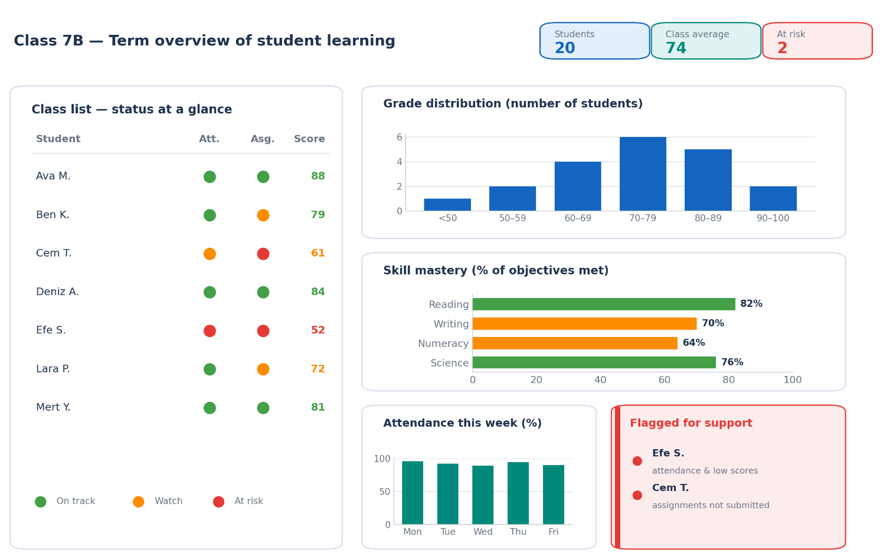
Figure 10. Illustrative educational dashboard displaying student performance indicators

Learning Activities and Resources
Discussion: Using data to support learning.
How could attendance, assessment and assignment data help you notice a student who needs support earlier? What risks or limits should be kept in mind?
Reflection. A learning dashboard flags a student as “at risk” based on low scores and attendance.
• What further information would you need before acting?
• How should the student’s privacy be protected?
• What could go wrong if the dashboard were trusted uncritically?
Activity. Using an anonymised class dataset, identify the topic with the lowest average score and propose one practical intervention.
Key Concepts
Concept | Definition
Data literacy | Reading, interpreting and using data responsibly
Learning analytics | Analysing learning data to support students
Educational dashboard | Selected learning indicators in one display
Data privacy & ethics | Protecting personal data and using it responsibly

References
Gašević, D., Dawson, S., & Siemens, G. (2014). Let’s not forget: Learning analytics are about learning. TechTrends 2014 59:1, 59(1), 64–71. https://doi.org/10.1007/S11528-014-0822-X
Kaliisa, R., Misiejuk, K., López-Pernas, S., Khalil, M., & Saqr, M. (2024). Have Learning Analytics Dashboards Lived Up to the Hype? A Systematic Review of Impact on Students’ Achievement, Motivation, Participation and Attitude. ACM International Conference Proceeding Series, 1, 295–304.
Mandinach, E. B., & Gummer, E. S. (2016). Data Literacy for Educators: Making It Count in Teacher Preparation and Practice.
Park, Y., & Jo, I. H. (2019). Factors that affect the success of learning analytics dashboards. Educational Technology Research and Development 2019 67:6, 67(6), 1547–1571. https://doi.org/10.1007/S11423-019-09693-0
Paulsen, L., & Lindsay, E. (2024). Learning analytics dashboards are increasingly becoming about learning and not just analytics - A systematic review. Education and Information Technologies 2024 29:11, 29(11), 14279–14308. https://doi.org/10.1007/S10639-023-12401-4
Schwendimann, B. A., Rodriguez-Triana, M. J., Vozniuk, A., Prieto, L. P., Boroujeni, M. S., Holzer, A., Gillet, D., & Dillenbourg, P. (2017). Perceiving learning at a glance: A systematic literature review of learning dashboard research. IEEE Transactions on Learning Technologies, 10(1), 30–41. https://doi.org/10.1109/TLT.2016.2599522
Siemens, G. (2013). Learning Analytics: The Emergence of a Discipline. American Behavioral Scientist, 57(10), 1380–1400.

