Information and Communication Technologies (ICT) for Smart Education
Author: Assoc. Prof. Emre Dandıl

Purpose
To improve teachers’ digital competencies and effective use of ICT tools in modern learning environments.

Learning Outcomes
Participants will be able to:
- Use digital learning environments effectively.
- Integrate ICT tools into teaching.
- Develop digital educational materials.
- Apply online collaboration tools.
- Design technology-enhanced learning activities.

Table of Contents
Purpose 2
Learning Outcomes 2
1. Digital Transformation in Education 4
1.1. Education 4.0 4
1.2. Digital Learning Environments 6
1.3. Future Classrooms 7
2. Learning Management Systems 10
3. Digital Content Creation 13
3.1. Presentation Design 13
3.2. Video Creation 14
3.3. Infographics 14
3.4. Interactive Content 15
3.5. Comparing Digital Content Creation Tools 16
4. Online Collaboration and Communication 18
4.1. Virtual Classrooms 18
4.2. Webinars 18
4.3. Digital Collaboration 18
4.4. Comparison of Online Communication and Collaboration Formats 19
5. Cybersecurity and Digital Safety 20
5.1. Safe Internet Use 21
5.2. Data Protection 21
5.3. GDPR Awareness 22
5.4. Digital Citizenship 22

Digital Transformation in Education
Digital transformation in education refers to the systematic redesign of teaching, learning, assessment and educational management through digital technologies. It differs from the simple adoption of software or devices because it involves changes in educational practices, organizational structures and decision-making processes (Bo & Bo, 2024; Vial, 2021)
The distinction between digitization, digitalization and digital transformation helps clarify this process, as seen in Table 1. Digitization means converting analogue information into digital form, such as scanning printed course materials. Digitalization involves using digital tools to improve an existing activity, such as collecting assignments through a learning-management system. Digital transformation goes further by reorganizing educational processes around new possibilities, including blended learning, digital assessment, collaboration and data-informed support (Verhoef et al., 2021).
Table 1. Digitization, Digitalization and Digital Transformation
Concept | Meaning | Educational example
Digitization | Converting analogue information into digital form | Saving printed course materials as PDF files
Digitalization | Improving an existing process through digital tools | Submitting and grading assignments online
Digital transformation | Redesigning educational practices and systems | Integrating blended learning, digital assessment and learning analytics

Education 4.0
Education 4.0 refers to an educational approach shaped by the technological and social changes associated with the Fourth Industrial Revolution. It focuses on preparing learners for rapidly changing environments through flexible, learner-centred and practice-oriented education. The concept concerns not only the use of digital technologies, but also changes in when, where and how learning takes place (Miranda et al., 2021; World Economic Forum., 2020).
Learning in Education 4.0 is not necessarily restricted to a fixed classroom or timetable. Digital platforms can provide access to materials, communication and learning activities at different times and locations. They can also support personalised and self-paced learning by allowing activities, resources and feedback to be adapted according to learner progress (Hussin, 2018; Shemshack & Spector, 2020). However, flexibility and personalization require clear guidance, reliable access and appropriate instructional design.
Education 4.0 also gives learners a more active role. Learners may make choices about project topics, resources or the ways in which they demonstrate their learning. Project-based, collaborative and hands-on activities enable them to apply knowledge to authentic problems while developing creativity, communication and problem-solving skills. Assessment may therefore include portfolios, projects, practical demonstrations and continuous feedback alongside traditional examinations (Hussin, 2018; World Economic Forum, 2023). Figure 1 summarizes the main characteristics of Education 4.0.
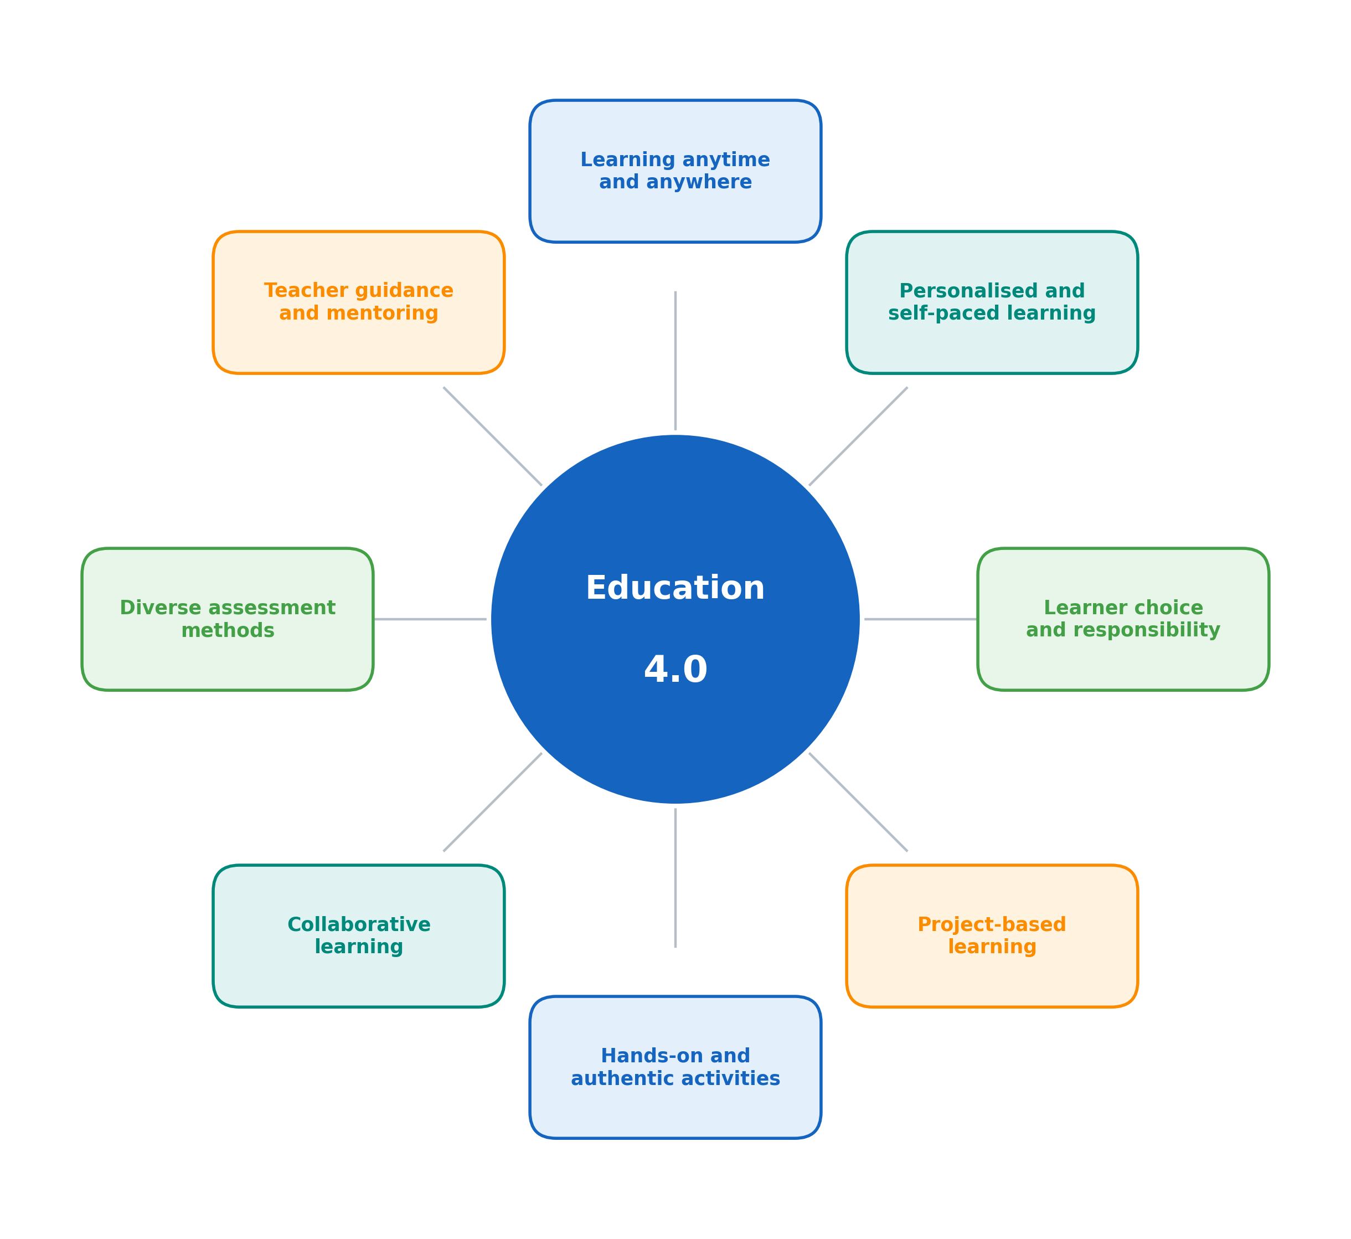
Figure 1. Main characteristics of Education 4.0
In this approach, teachers guide learning, organize meaningful activities and provide feedback rather than functioning only as sources of information. Technology supports this process, but it does not define Education 4.0 by itself. The central change is the movement towards learning that is flexible, applied, collaborative and responsive to learners’ needs (Redecker, 2017).

Digital Learning Environments
A digital learning environment is an organized digital space in which learning resources, activities, communication and assessment are brought together. It may be built around a learning-management system and supported by tools such as video conferencing, shared documents, simulations and digital assessment applications. Digital learning environments can be used in online, blended and technology-supported face-to-face education (Turnbull et al., 2020).
Digital learning environments also connect different stages of the learning process (Figure 2). A learner may first access a resource, participate in an activity, submit an assignment and then receive feedback within the same environment. Teachers can use this structure to manage course content, communicate expectations and follow learner participation. The effectiveness of the environment therefore depends on how well its functions are connected to the learning design rather than on the quantity of technology it contains (Bond et al., 2018).
Technical and instructional support are also necessary. Clear guidance, accessible materials and reliable access help learners use the environment effectively. Institutions should therefore consider usability, accessibility, data protection and technical assistance when selecting or designing digital learning environment (European Commission, 2020)
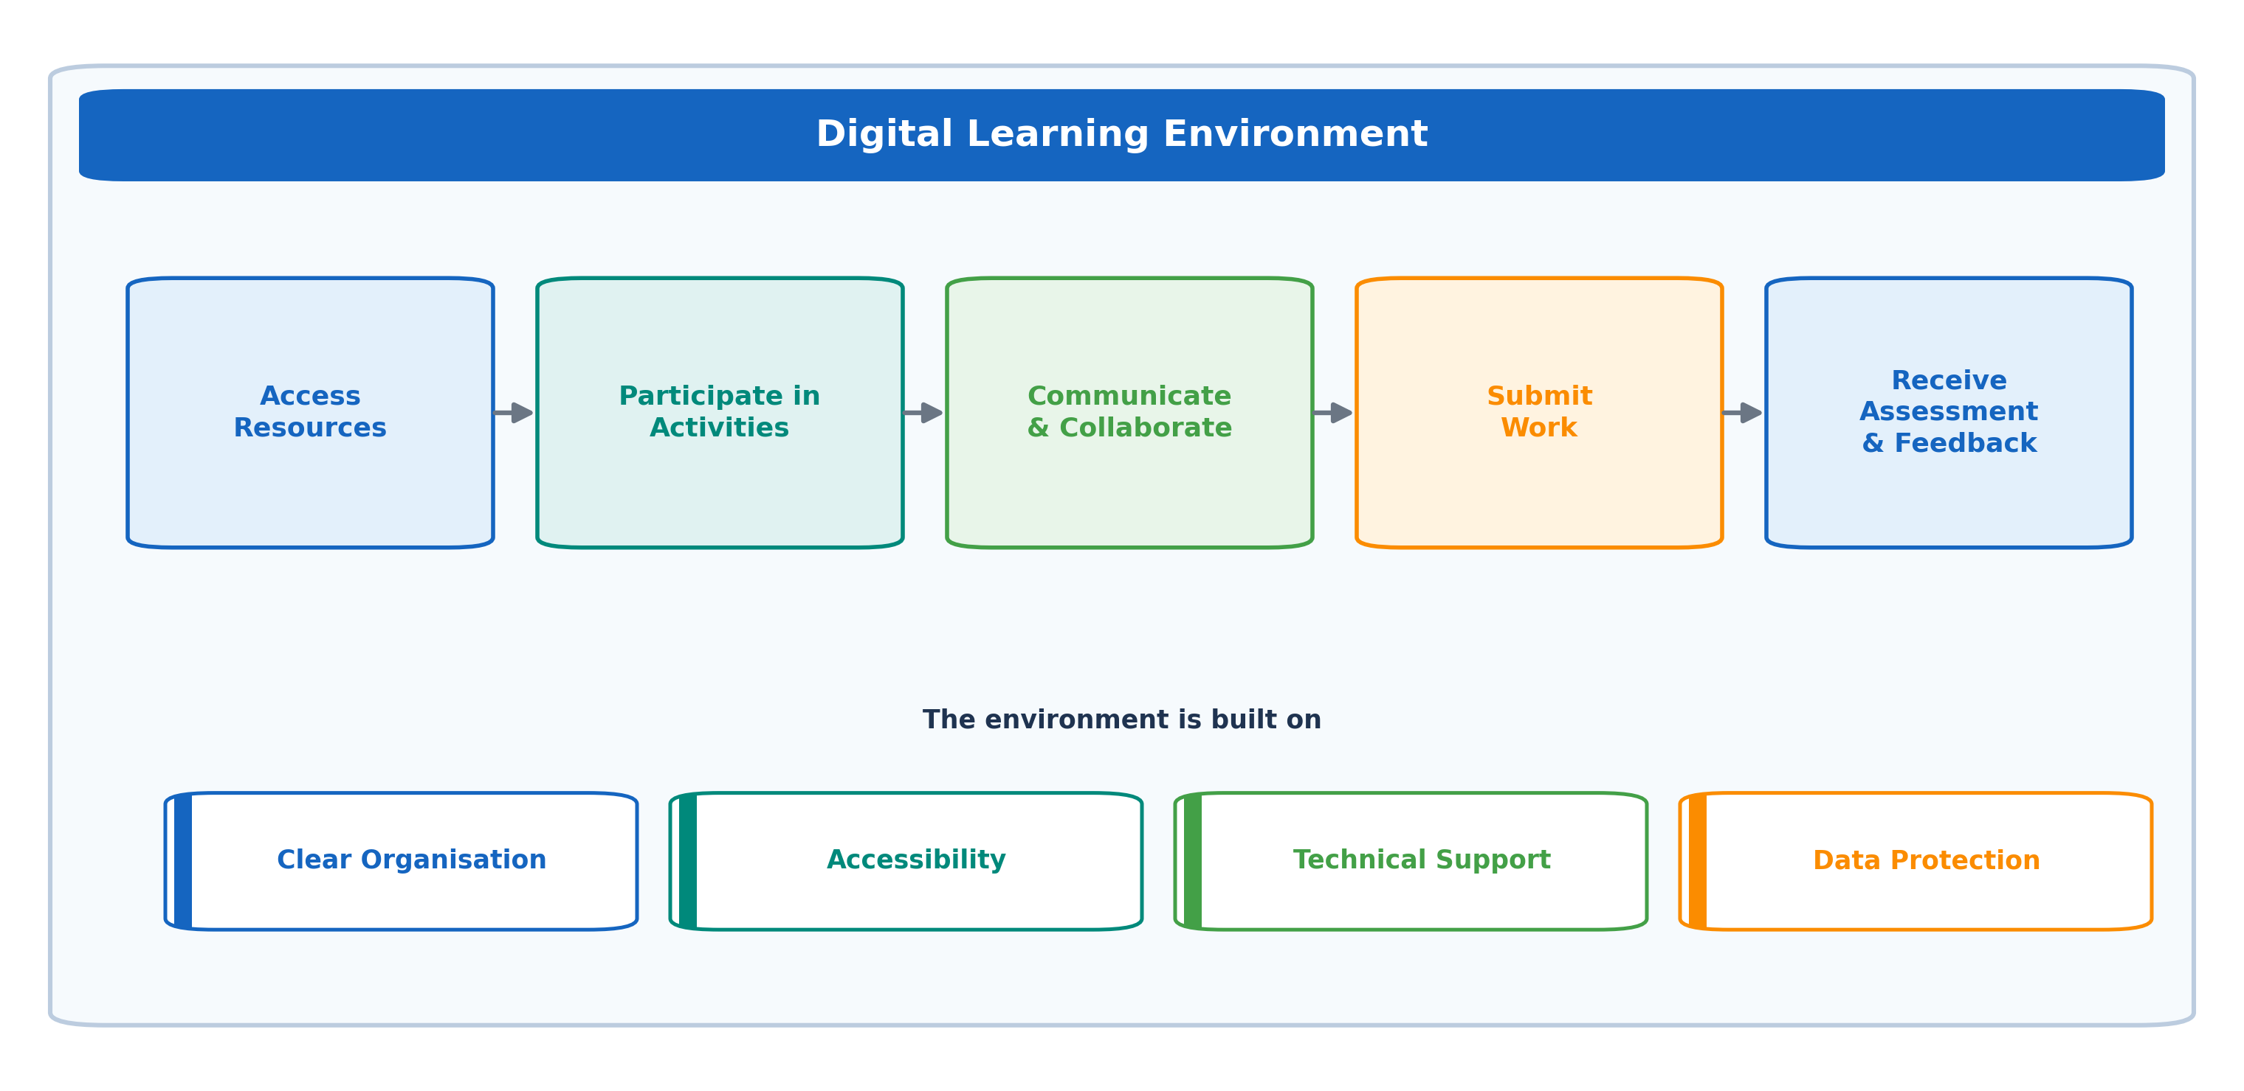
Figure 2. Learning process within a digital learning environment

Future Classrooms
Future classrooms are learning spaces designed to support different forms of participation, including individual work, collaboration, discussion, experimentation and presentation. Their defining feature is not the amount of technology they contain, but their ability to adapt to different learning activities. Movable furniture, shared work areas, digital production tools and spaces for focused study can help the classroom shift from one type of activity to another without relying on a fixed arrangement for every lesson (Of Science & Education, 2024).
These classrooms also connect physical and digital learning. Learners may investigate a topic in class, collaborate through a shared platform, create digital content and continue the same activity outside the classroom. The Future Classroom Lab represents this approach through six activity zones—Investigate, Create, Present, Interact, Exchange and Develop—which emphasize what learners do within the space rather than which devices are available, as seen in Figure 3 (Bo & Bo, 2024; Of Science & Education, 2024).
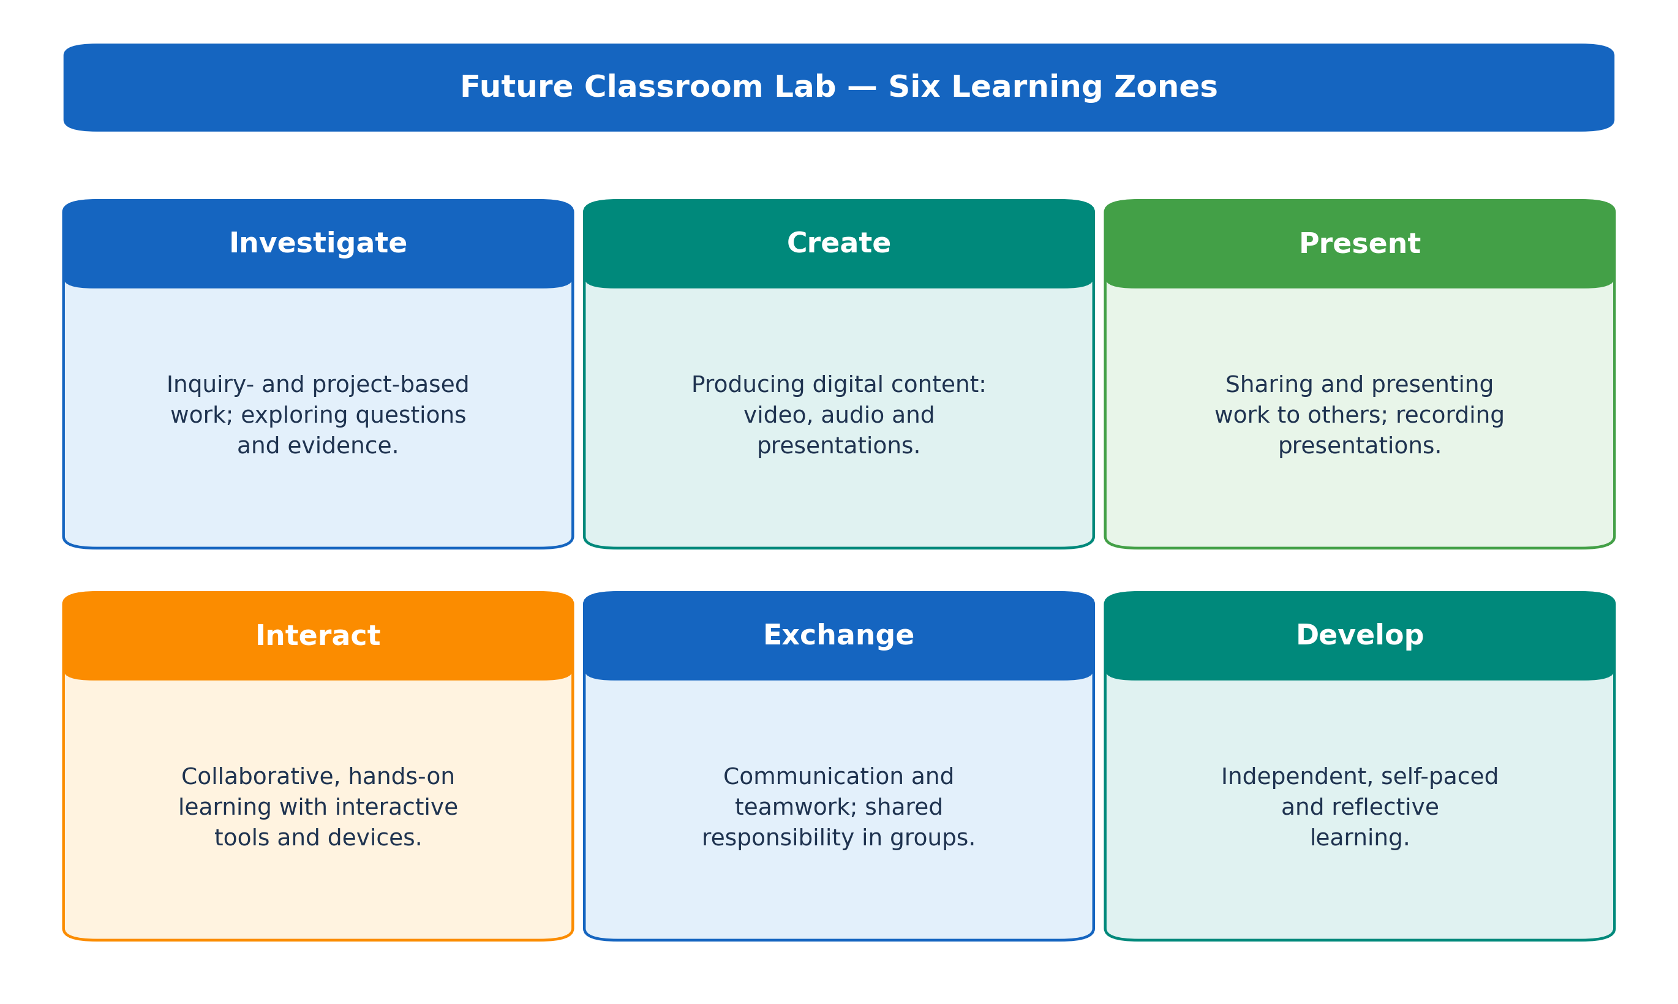
Figure 3. The six learning zones of the Future Classroom Lab.

Learning Activities and Resources
Discussion — The Future Teacher: in small groups, discuss how the role of the teacher changes as education becomes more digital. Which tasks can technology support, and which remain essentially human?
Reflection. A school scans its paper handouts, then collects assignments through an LMS, and finally redesigns its courses around blended learning and data-informed support.
• Which step is digitization, which is digitalization, and which is digital transformation?
• What new opportunities does the last step create, and what does it require?
Key Concepts
Concept | Definition
Digitization | Converting analogue information into digital form
Digitalization | Using digital tools to improve an existing activity
Digital transformation | Reorganising education around new digital possibilities
Education 4.0 | Learner-centred education for a rapidly changing world

Recommended Resources
• OECD Digital Education Outlook: https://www.oecd.org/education/digital-education-outlook.htm
• Future Classroom Lab (European Schoolnet): https://fcl.eun.org

References
Bo, N. S. W., & Bo, N. S. W. (2024). OECD digital education outlook 2023: Towards an effective education ecosystem. Hungarian Educational Research Journal, 15(2), 284–289. https://doi.org/10.1556/063.2024.00340
Bond, M., Marín, V. I., Dolch, C., Bedenlier, S., & Zawacki-Richter, O. (2018). Digital transformation in German higher education: student and teacher perceptions and usage of digital media. International Journal of Educational Technology in Higher Education 2018 15:1, 15(1), 48-. https://doi.org/10.1186/S41239-018-0130-1
European Commission. (2020). Digital Education Action Plan: Resetting Education and Training for the Digital Age. European Commission: Brussels, Belgium. https://education.ec.europa.eu/focus-topics/digital-education/actions/plan
Hussin, A. A. (2018). Education 4.0 Made Simple: Ideas for Teaching. International Journal of Education and Literacy Studies, 6(3), 92–98. https://doi.org/10.7575/aiac.ijels.v.6n.3p.92
Miranda, J., Navarrete, C., Noguez, J., Molina-Espinosa, J. M., Ramírez-Montoya, M. S., Navarro-Tuch, S. A., Bustamante-Bello, M. R., Rosas-Fernández, J. B., & Molina, A. (2021). The core components of education 4.0 in higher education: Three case studies in engineering education. Computers & Electrical Engineering, 93, 107278. https://doi.org/10.1016/J.COMPELECENG.2021.107278
Of Science, R., & Education, I. (2024). The Future Classroom Lab. Educational considerations from a systematic review. Review of Science, Mathematics and ICT Education, 18(2), 49–68. https://doi.org/10.26220/REV.5044
Redecker, C. (2017). European framework for the digital competence of educators: DigCompEdu. Joint Research Centre (JRC) Science for Policy Report, 95. https://doi.org/10.2760/159770
Shemshack, A., & Spector, J. M. (2020). A systematic literature review of personalized learning terms. Smart Learning Environments, 7(1), 33-.
Turnbull, D., Chugh, R., & Luck, J. (2020). Learning Management Systems, An Overview. Encyclopedia of Education and Information Technologies, 1052–1058.
Verhoef, P. C., Broekhuizen, T., Bart, Y., Bhattacharya, A., Qi Dong, J., Fabian, N., & Haenlein, M. (2021). Digital transformation: A multidisciplinary reflection and research agenda. Journal of Business Research, 122, 889–901. https://doi.org/10.1016/J.JBUSRES.2019.09.022
Vial, G. (2021). Understanding digital transformation: A review and a research agenda. Managing Digital Transformation, 13–66. https://doi.org/10.4324/9781003008637-4
World Economic Forum. (2020). Schools of the Future: Defining New Models of Education for the Fourth Industrial Revolution. World Economic Forum.
World Economic Forum. (2023). Defining Education 4.0: A Taxonomy for the Future of Learning. World Economic Forum.

Learning Management Systems
A learning management system is a digital platform used to organize and manage teaching and learning activities. It provides a central environment for course materials, assignments, communication, assessment and learner records. LMS platforms may support online, blended and face-to-face education by bringing course delivery and administration together within a single system (Altinpulluk & Kesim, 2021).
The educational value of an LMS depends on how clearly the learning process is structured. Learners should be able to locate materials, understand task requirements, submit work and access feedback without unnecessary difficulty. Platform selection should therefore consider course design, institutional infrastructure and user needs.
Moodle, Google Classroom and Microsoft Teams are commonly used to support these processes, but they organize learning in different ways. Moodle is built around configurable course sections and activities, Google Classroom provides a streamlined workflow for classwork and assignments, and Microsoft Teams combines course functions with communication and collaboration. Their main characteristics are outlined below.
- Moodle is an open-source learning management system that supports detailed course organization, varied learning activities and multiple assessment methods. Courses can be organized by week or topic, while assignments, quizzes, forums, grading and completion tracking can be managed within the same environment. Its open-source structure also allows institutions to extend the platform through plugins and local customization (Moodle, n.d.).
- Google Classroom is a cloud-based classroom platform organized around areas such as Stream, Classwork, People and Grades. The Classwork area can contain materials, assignments, questions and quizzes organized by topic. Its connection with Google Drive and Docs supports a workflow in which educators distribute files, learners submit work and completed assignments are returned with grades and feedback (Google, n.d.).
- Microsoft Teams for Education combines communication, meetings, files, assignments and grades through class teams and channels. Each class team may also include Class Notebook, which provides a content library, a collaborative workspace and private areas for individual learners. Channels can be used to organize conversations, resources and applications around subjects or projects (Microsoft, n.d.).
The differences among these platforms become clearer when they are considered in relation to a learning activity. For example, an educator delivering a structured online course may use Moodle to organize weekly units, set completion requirements and administer quizzes. Google Classroom may be used to distribute a project brief, assign an individual document to each learner and return the completed work with feedback. Microsoft Teams may support a collaborative project through group channels, online meetings and shared files. These are illustrative uses rather than fixed rules, because each platform can support a broader range of activities (Table 2).

Table 2. Comparison of Moodle, Google Classroom and Microsoft Teams
Criterion | Moodle | Google Classroom | Microsoft Teams
Platform type | Open-source LMS | Cloud-based classroom platform | Communication and collaboration platform
Course organization | Sections organized by week or topic | Classwork organized through topics | Class teams, channels and Classwork modules
Customization | High; plugins and local configuration | Limited within Google Workspace | Moderate within Microsoft 365
Main emphasis | Structured activities and assessment | Materials, assignments and feedback | Communication and collaborative learning
Institutional requirement | May require hosting and technical administration | Requires an appropriate Google account or Workspace environment | Requires a Microsoft 365 education environment

Learning Activities and Resources
Workshop — Creating a Moodle course: create a short course in Moodle (or MoodleCloud). Add a “Week 1” section with a resource, an assignment and a quiz, then compare the setup process with Google Classroom or Microsoft Teams.
Discussion. For a course that needs detailed assessment, and for one that needs quick sharing of materials, which platform would you choose, and why?
Key Concepts
Concept | Definition
Learning management system | A platform for organizing and delivering courses online
Course format | Organizing content by week, topic or another structure
Open-source software | Software that can be freely adapted and extended (e.g. Moodle)
Blended learning | Combining online and face-to-face teaching

Recommended Resources (documentation)
• Moodle – Documentation: https://docs.moodle.org
• Google Classroom – Help Center: https://support.google.com/edu/classroom
• Microsoft Teams for Education – Help: https://support.microsoft.com/en-us/teams
• MoodleCloud (free trial for hands-on practice): https://moodlecloud.com

References
Altinpulluk, H., & Kesim, M. (2021). A SYSTEMATIC REVIEW OF THE TENDENCIES IN THE USE OF LEARNING MANAGEMENT SYSTEMS. Turkish Online Journal of Distance Education, 22(3), 40–54. https://doi.org/10.17718/TOJDE.961812
Google. (n.d.). Google Classroom Help. Retrieved July 19, 2026, from https://support.google.com/edu/classroom#topic=10298088
Microsoft. (n.d.). Microsoft Teams help & learning| Microsoft Support. Microsoft. Retrieved July 19, 2026, from https://support.microsoft.com/en-us/teams/
Moodle. (n.d.). Moodle documentation. Moodle. Retrieved July 19, 2026, from https://docs.moodle.org/502/en/Main_page

Digital Content Creation
Digital content creation involves producing learning materials through text, images, audio, video and interactive elements. These materials may be used to explain concepts, demonstrate procedures, present data or support practice. Their design should be guided by the learning objective, the intended audience and the type of information being communicated. Multimedia can support understanding when related elements are organized clearly and unnecessary detail is avoided (Mayer & Fiorella, 2021).
The most appropriate format depends on what learners are expected to do. Presentations are useful for structured explanations, videos for processes and demonstrations, infographics for visual summaries, and interactive content for practice and feedback.

Presentation Design
Presentations organise information into a sequence of slides. Each slide should communicate one main point, while the complete sequence should help learners follow the development of the subject. Concise text, relevant visuals and consistent formatting are generally more effective than dense paragraphs and heavily decorated layouts.
Canva can support visual consistency through templates and layout tools, while Genially may be used when clickable elements, embedded media or non-linear navigation are required. Figure 4 compares a text-heavy slide with a simplified educational slide.
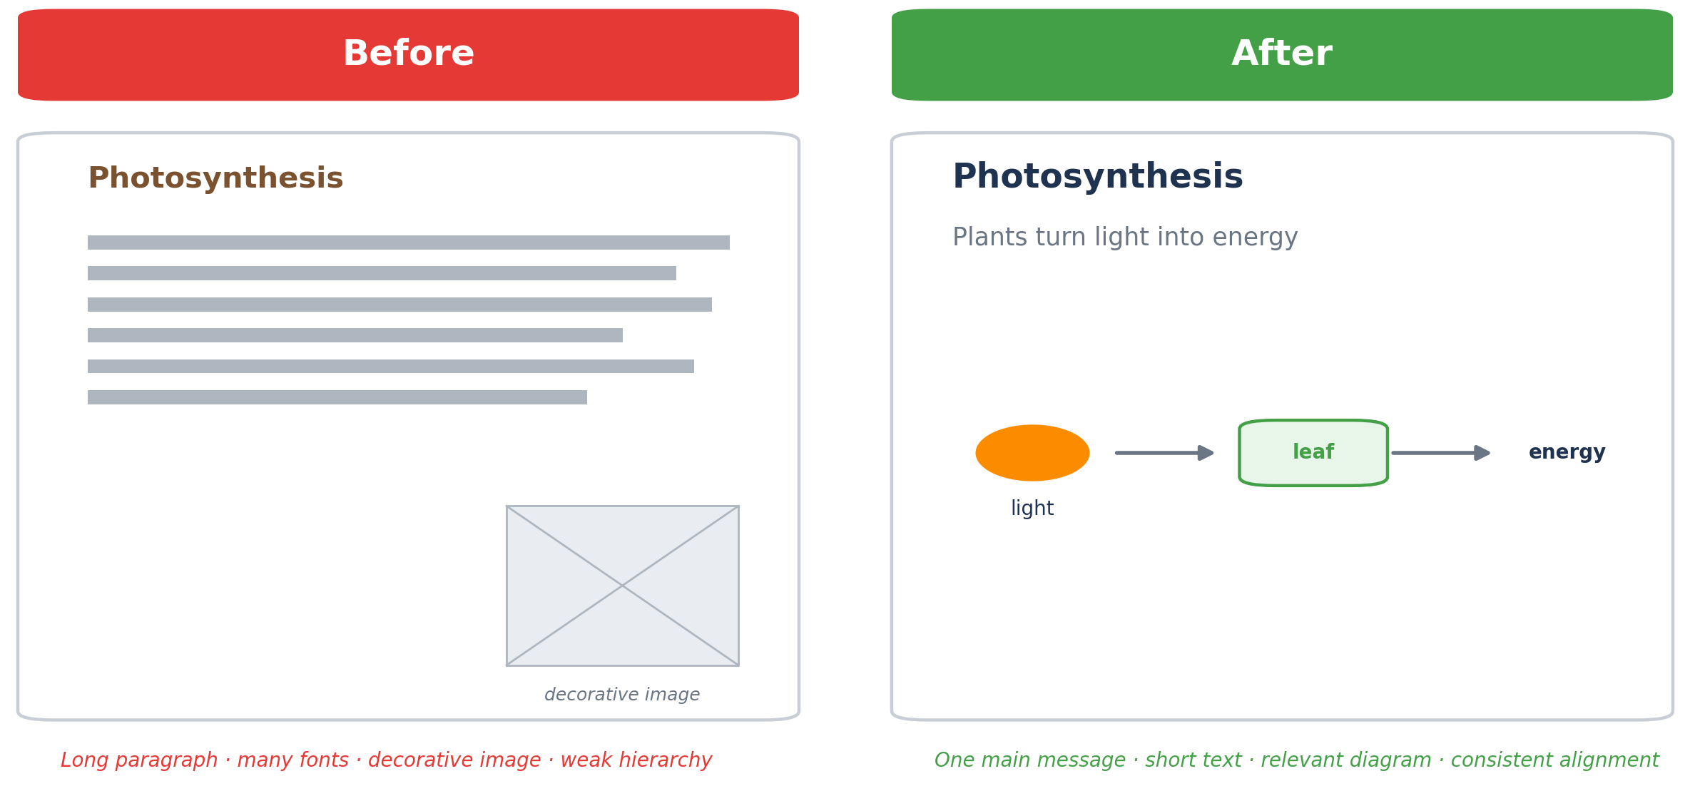
Figure 4. Comparison of a text-heavy slide and a simplified presentation slide.

Video Creation
Educational videos are useful for explaining processes, demonstrating procedures and presenting examples that develop over time. Effective production usually begins with a short script or storyboard that coordinates narration, visuals and examples. Dividing the explanation into focused sections can help learners follow the content more easily.
Research on instructional video suggests that shorter, focused and segmented recordings generally support engagement more effectively than long recordings of conventional lectures (Guo et al., 2014). Powtoon can be used for animated explanations, while Canva supports the combination of video, text, graphics, narration and transitions. Figure 5 presents a basic educational video storyboard.
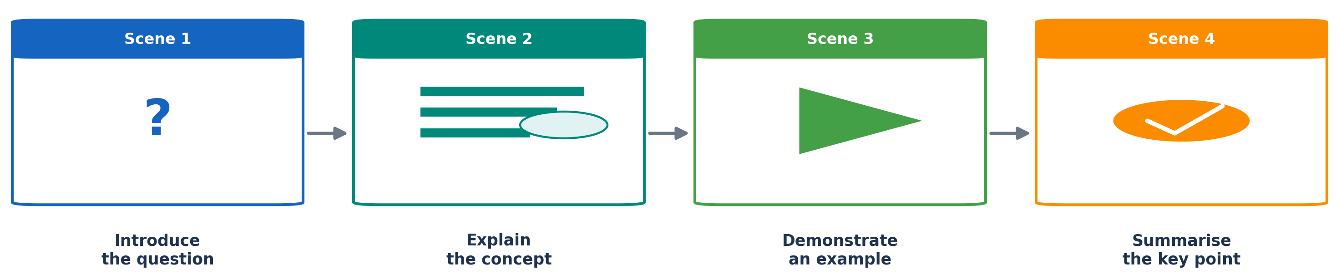
Figure 5. Basic storyboard for an educational video

Infographics
Infographics combine short text, data, icons and charts to communicate a focused message. They are suitable for presenting processes, comparisons, classifications and numerical summaries. A clear reading order should guide the viewer from the main subject to supporting details.
Values, labels and measurement units should be visible, while visual elements should represent the information accurately. Canva can be used for static infographic design, whereas Genially can add clickable labels, media and expandable information when additional detail is required. Figure 6 presents the basic structure of an educational infographic.
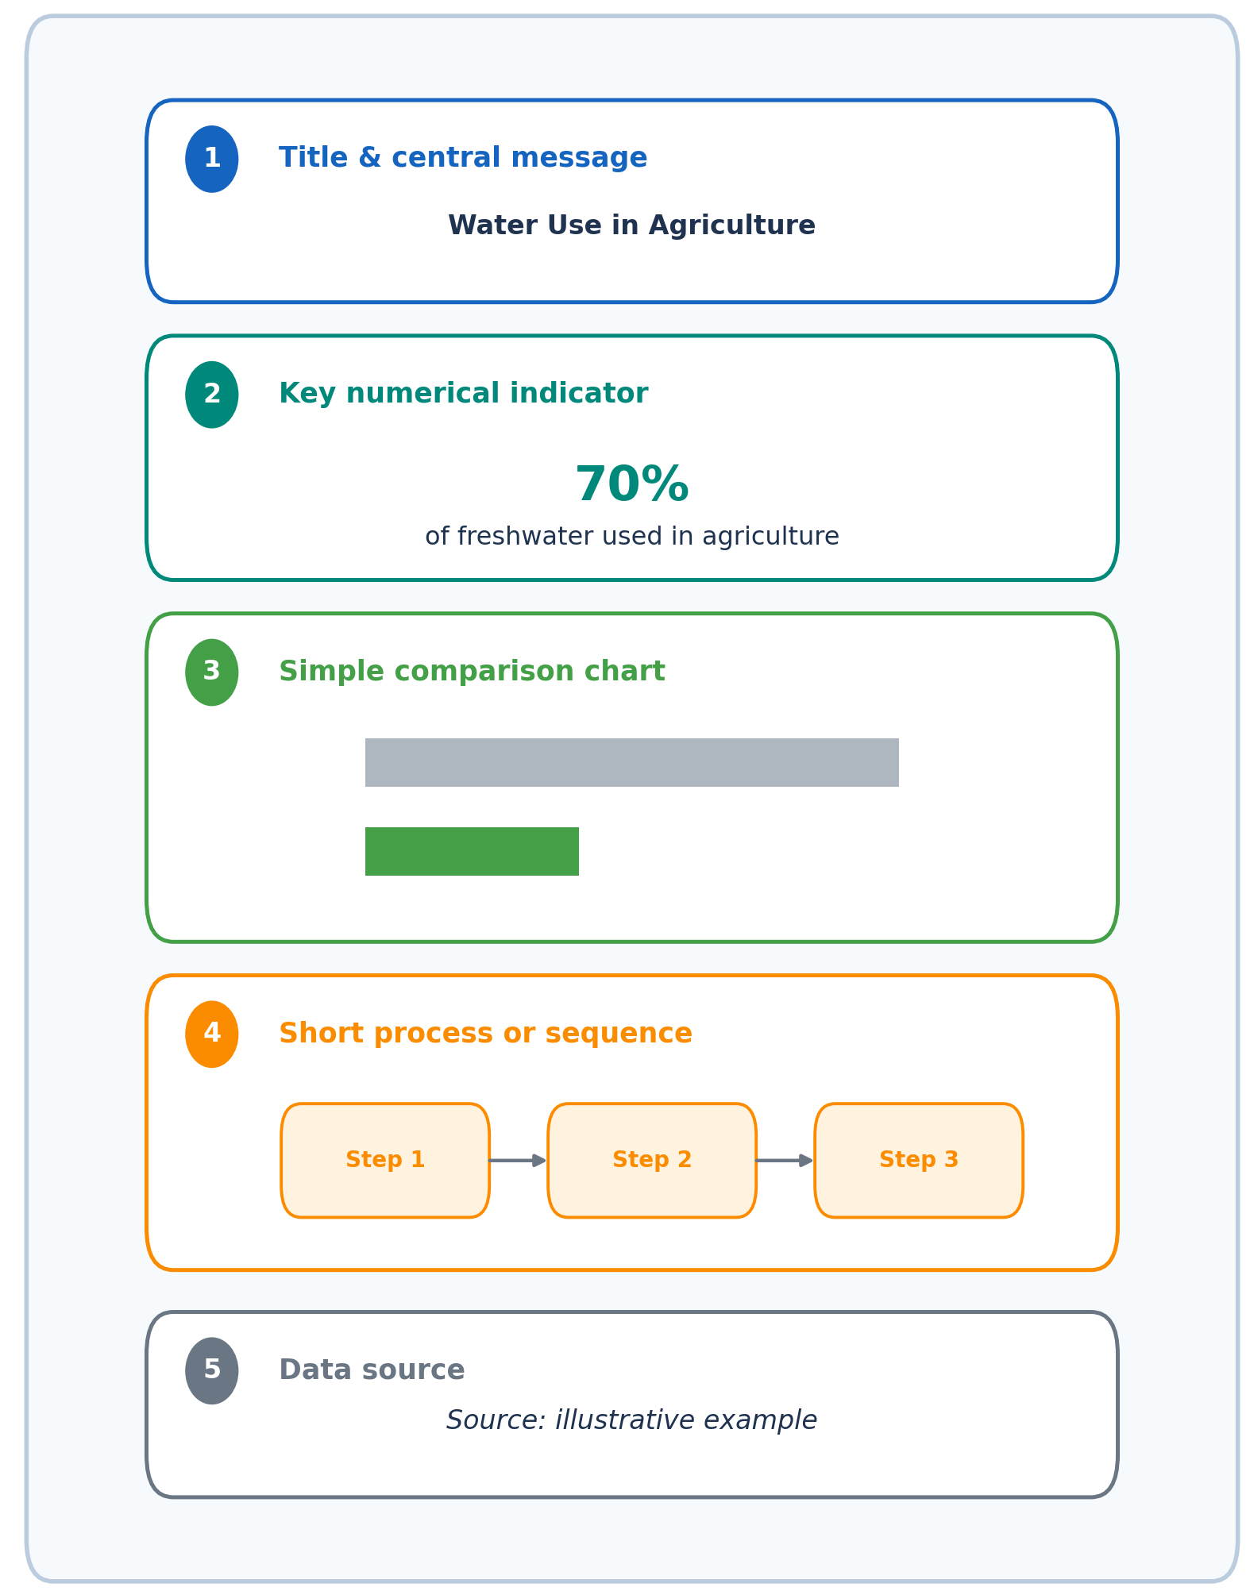
Figure 6. Basic structure of an educational infographic.

Interactive Content
Interactive content requires learners to respond, make choices or explore information. Common formats include quizzes, interactive videos, image hotspots, drag-and-drop activities and branching scenarios. These formats can be used to check understanding, practice a skill or provide feedback during learning.
H5P offers a wide range of interactive content types that can be integrated into compatible learning-management systems. Genially can also be used to create interactive presentations, images and quizzes. Figure 7 illustrates the basic interaction cycle.

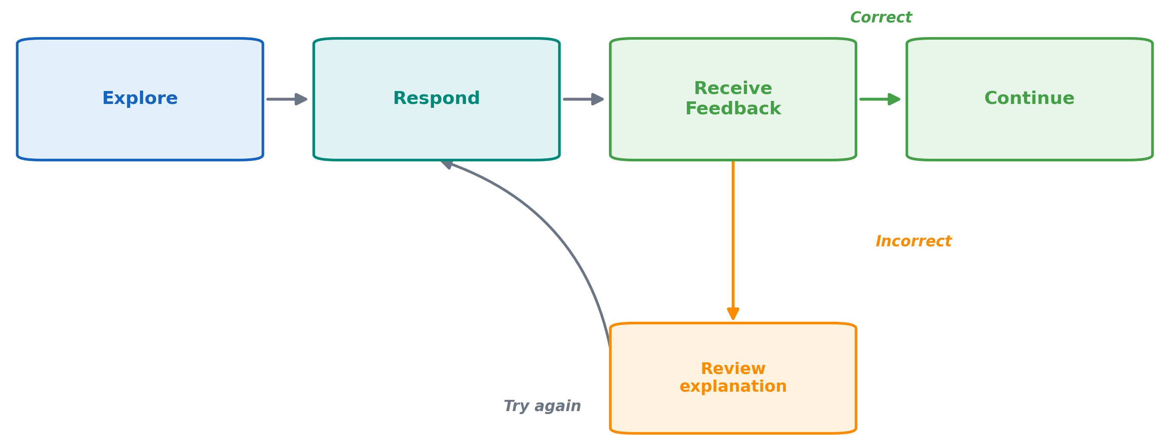
Figure 7. Interaction and feedback cycle in digital content.

Comparing Digital Content Creation Tools
Several tools can support digital content creation, and many of them overlap in what they offer. Rather than learning every feature of each application, it is more useful to match a tool to the content type and the learning task at hand. Table 3 summarizes four widely used tools, their main content types and the situations in which each is most appropriate.
Table 3. Digital content creation tools and their main uses.
Tool | Main content types | Distinguishing feature | Example educational use
Canva | Presentations, videos and infographics | Templates and visual layout tools | Designing a lesson presentation or visual summary
Genially | Interactive presentations, images and infographics | Clickable and expandable elements | Creating an exploratory diagram or interactive infographic
Powtoon | Animated videos and presentations | Scene-based animated production | Explaining a process through an animated video
H5P | Quizzes, interactive videos and branching activities | Learner response and immediate feedback | Adding questions to a video or creating a practice activity

Learning Activities and Resources
Workshop — Creating an interactive learning object: using H5P or Genially, create a short interactive item (for example an interactive video or a set of image hotspots) for a topic you teach. Include at least one question that gives learners feedback.
Reflection. Take one of your existing slides and redesign it around a single main message, short supporting text, a relevant visual and consistent alignment. What did you remove, and why?
Key Concepts
Concept | Definition
Multimedia principle | Combining words and visuals to support understanding
Cognitive load | Avoiding unnecessary detail so learners can focus
Segmentation | Dividing content, such as a video, into focused parts
Interactivity | Content that responds to the learner’s actions

Recommended Resources
• Canva: https://www.canva.com
• Genially: https://genially.com
• Powtoon: https://www.powtoon.com
• H5P: https://h5p.org

References
Guo, P. J., Kim, J., & Rubin, R. (2014). How video production affects student engagement: An empirical study of MOOC videos. L@S 2014 - Proceedings of the 1st ACM Conference on Learning at Scale, 41–50.
Mayer, R. E., & Fiorella, L. (2021). The Cambridge Handbook of Multimedia Learning. The Cambridge Handbook of Multimedia Learning, 1–608. https://doi.org/10.1017/9781108894333

Online Collaboration and Communication
Online collaboration and communication involve the use of digital environments to support live teaching, structured online events and shared group work. These activities may take place synchronously, asynchronously or through a combination of both. Their effectiveness depends not only on the selected technology, but also on how participation, interaction and learner responsibilities are organized (Hammond, 2016; Warden et al., 2013).
Zoom, Microsoft Teams, Google Meet and Padlet support different parts of this process. Zoom provides live meeting and webinar functions such as screen sharing, polling and breakout rooms. Microsoft Teams combines meetings with channels, shared files and Microsoft 365 applications, allowing communication and group work to continue beyond a single session. Google Meet supports scheduled video meetings within Google Workspace, while Padlet provides a shared visual board for posting ideas, media, links and feedback. These tools should therefore be selected according to the type and duration of the activity rather than treated as interchangeable platforms.

Virtual Classrooms
Virtual classrooms are synchronous learning environments in which educators and learners meet at the same time. They may combine explanation, screen sharing, discussion, questions and small-group activities. Their educational value lies in creating opportunities for interaction and presence rather than simply transferring a lecture to an online meeting platform. Research indicates that teacher–learner and learner–learner interaction can influence engagement and perceptions of the online learning experience (Blaine, 2019).
A virtual lesson may begin with a short explanation, continue with a poll or question and then move into a breakout activity. Zoom, Microsoft Teams and Google Meet can all support this type of lesson, although the available functions may vary according to institutional licenses and settings.

Webinars
Webinars are structured online events in which one or more presenters deliver content to an audience. Compared with virtual classrooms, participant roles are more clearly separated and interaction is usually managed through polls, chat or question-and-answer functions. Webinars are therefore suitable for expert presentations, demonstrations, public information sessions and professional development involving larger groups.
Educational webinars require more than a presenter and a slide deck. Clear moderation, planned audience participation and time for questions help maintain attention and allow participants to connect the presentation with their own context. Zoom and Microsoft Teams provide dedicated webinar functions in supported plans.

Digital Collaboration
Digital collaboration involves participants working together to develop a shared resource, decision or product. It may take place during a live meeting or continue asynchronously over several days or weeks. Examples include collaborative reports, shared presentations, group research, brainstorming and peer feedback.
Microsoft Teams supports continued collaboration through channels, shared documents and connected applications. Padlet offers a more visual structure in which participants can contribute posts, media and comments to a common board. Online collaboration is more effective when the task, participant roles and expected outcome are clearly defined (Hammond, 2016; Vogel et al., 2017).

Comparison of Online Communication and Collaboration Formats
Virtual classrooms, webinars and digital collaboration environments may use some of the same tools, but they organise participation in different ways. The distinction is based less on the platform itself and more on who controls the activity, how participants contribute and whether the work is completed during a live session or continues over time. Table 4 summarizes these differences.
Table 4. Comparison of online communication and collaboration formats.
Format | Organization | Main form of participation | Example educational use | Supporting tools
Virtual classroom | Live and instructor-guided | Discussion, questions and small-group activity | Online lesson or tutorial | Zoom, Microsoft Teams, Google Meet
Webinar | Live and presenter-led | Listening, polls and questions | Expert talk or professional-development session | Zoom, Microsoft Teams
Digital collaboration | Live or asynchronous | Shared production and peer feedback | Group project, brainstorming or peer review | Microsoft Teams, Padlet

Learning Activities and Resources
Activity — Design an online session: plan a short learning sequence that combines two formats — for example, introduce a topic in a webinar, discuss it in a virtual classroom, and develop it further on a shared board. Note where synchronous and asynchronous work fit.
Discussion. For a group task that runs over two weeks, which parts should be synchronous and which asynchronous?
Key Concepts
Concept | Definition
Synchronous communication | Interaction that takes place at the same time (live)
Asynchronous communication | Interaction over a period, not in real time
Collaboration script | A clear structure of task, roles and expected outcome
Online presence | The sense of interacting with real people online

Recommended Resources
• Zoom: https://zoom.us
• Microsoft Teams: https://www.microsoft.com/microsoft-teams
• Google Meet: https://meet.google.com
• Padlet: https://padlet.com

References
Blaine, A. M. (2019). Interaction and presence in the virtual classroom: An analysis of the perceptions of students and teachers in online and blended Advanced Placement courses. Computers & Education, 132, 31–43. https://doi.org/10.1016/J.COMPEDU.2019.01.004
Hammond, M. (2016). Online collaboration and cooperation: The recurring importance of evidence, rationale and viability. Education and Information Technologies 2016 22:3, 22(3), 1005–1024. https://doi.org/10.1007/S10639-016-9469-X
Vogel, F., Wecker, C., Kollar, I., & Fischer, F. (2017). Socio-Cognitive Scaffolding with Computer-Supported Collaboration Scripts: a Meta-Analysis. Educational Psychology Review, 29(3), 477–511.
Warden, C. A., Stanworth, J. O., Ren, J. B., & Warden, A. R. (2013). Synchronous learning best practices: An action research study. Computers & Education, 63, 197–207. https://doi.org/10.1016/J.COMPEDU.2012.11.010

Cybersecurity and Digital Safety
As teaching and learning increasingly depend on digital platforms, educators and learners routinely manage personal information, access online services and communicate through networked environments. Cybersecurity and digital safety therefore extend beyond technical protection. They include safeguarding personal data, recognizing online risks and participating responsibly in digital spaces (Vuorikari et al., 2022).

Safe Internet Use
Safe internet use requires users to recognize common threats such as phishing, malicious downloads, insecure websites and attempts to obtain personal information. Many risks can be reduced through a limited number of consistent practices:
- Use strong and unique passwords. Important accounts should not share the same password. A password manager can support the secure creation and storage of complex credentials.
- Enable multi-factor authentication. A second verification method can prevent access even when a password has been exposed.
- Keep software updated. Operating systems, browsers and applications should be updated regularly because security patches address known vulnerabilities.
- Verify unexpected messages and links. Users should check the sender, destination address and purpose of a request before downloading files or entering account information.
- Maintain secure backups. Important files should be backed up so that they can be recovered after accidental loss, device failure or ransomware.
In education, these practices are reinforced when teachers apply them consistently and explain the reasoning behind them. Safe online behaviour then becomes part of normal digital practice rather than a response introduced only after a problem occurs (Vuorikari et al., 2022).

Data Protection
Educational institutions process many forms of personal data, including names, contact information, attendance records, assessment results and learning-platform activity. Protecting this information requires attention to the entire data lifecycle, from collection to deletion. The main principles include:
- Data minimization: collect only the information required for a defined educational or administrative purpose.
- Secure storage: use approved systems with appropriate access controls and protection measures.
- Restricted access: make information available only to individuals who need it for their role.
- Controlled sharing: disclose personal data only when there is a clear and lawful reason.
- Limited retention: delete or anonymize information when it is no longer required.
Teachers should follow institutional policies when using online services, particularly when platforms process information outside the institution or transfer data across national borders. Free or easily accessible applications should not be assumed to provide appropriate protection simply because they are widely used (European Parliament & Council of the European Union, 2016).

GDPR Awareness
The General Data Protection Regulation has governed the processing of personal data in the European Union since 2018. Under the GDPR, a data controller determines the purposes and methods of processing, while a data processor handles information on the controller’s behalf. Educational institutions commonly act as controllers, whereas external digital platforms may act as processors (European Parliament & Council of the European Union, 2016)
The regulation requires personal data to be processed lawfully, fairly and transparently. It also grants individuals several rights, including:
- The right to be informed: individuals should know what information is collected, why it is needed and how long it will be retained.
- The right of access: individuals may request a copy of the personal data held about them.
- The right to rectification: inaccurate or incomplete information may be corrected.
- The right to erasure: information may be deleted when the relevant legal conditions are met.
For educators, GDPR awareness means following institutional procedures, using approved tools and understanding the purpose for which learner information is processed. Consent may be appropriate in some situations, but it is not the only lawful basis for processing. When the correct procedure is unclear, educators should consult the institution’s data-protection officer or other responsible personnel rather than making an individual legal judgement.

Digital Citizenship
Digital citizenship refers to competent, ethical and responsible participation in digital society. It includes not only protection from online harm, but also the ability to communicate, create, evaluate information and exercise rights responsibly (Richardson & Milovidov, 2019).
Important dimensions of digital citizenship include:
- Respectful communication: applying appropriate standards of conduct in messages, discussions and shared online spaces.
- Digital-footprint awareness: recognising that posts, images and interactions may remain accessible and influence future perceptions.
- Respect for intellectual property: using, adapting and acknowledging digital content appropriately.
- Critical evaluation: examining the source, accuracy and purpose of online information before accepting or sharing it.
- Digital well-being: managing screen use, protecting privacy and responding appropriately to cyberbullying or other harmful behaviour.
Digital citizenship is most effectively developed across subjects and activities rather than taught as an isolated topic. When learners repeatedly evaluate sources, acknowledge digital content, communicate respectfully and protect personal information, responsible participation becomes part of everyday learning.
Learning Activities and Resources
Discussion. How can you help learners stay safe online without discouraging their use of digital tools?
Self-Assessment (choose the best answer)
1. Which is the strongest password practice?
a) Using the same strong password everywhere
b) A unique password for each account, kept in a password manager
c) A short password that is easy to remember
d) Sharing passwords with trusted colleagues
2. Under the GDPR, individuals have the right to…
a) sell their personal data
b) access, correct and, in some cases, erase their data
c) avoid all data collection
d) ignore consent requirements
3. “Data minimization” means…
a) collecting as much data as possible
b) collecting only the data genuinely needed
c) deleting all data immediately
d) storing data in several places
4. Digital citizenship is mainly about…
a) buying digital products
b) responsible, ethical and respectful participation online
c) owning the newest devices
d) advanced coding skills
Answers: 1-b, 2-b, 3-b, 4-b
Key Concepts
Concept | Definition
Two-factor authentication | A second identity check beyond the password
Data minimisation | Collecting only the data that is genuinely needed
Data controller / processor | Who decides on, versus who carries out, data processing
Digital footprint | The lasting traces left by online activity

Recommended Resources
• DigComp 2.2 – Digital Competence Framework: https://publications.jrc.ec.europa.eu/repository/handle/JRC128415
• DigCompEdu – framework for educators: https://joint-research-centre.ec.europa.eu/digcompedu_en
• EU Digital Education Action Plan: https://education.ec.europa.eu/focus-topics/digital-education/action-plan
• Council of Europe – Digital Citizenship Education: https://www.coe.int/en/web/digital-citizenship-education

References
European Parliament & Council of the European Union. (2016). Regulation (EU) 2016/679 of the European Parliament and of the Council of 27 April 2016 on the protection of natural persons with regard to the processing of personal data and on the free movement of such data. Official Journal of the European Union. http://data.europa.eu/eli/reg/2016/679/oj
Richardson, J., & Milovidov, E. (2019). Digital citizenship education handbook: Being online, well-being online, rights online. Council of Europe.
Vuorikari, R., Kluzer, S., & Punie, Y. (2022). DigComp 2.2. The Digital Competence Framework for Citizens. With new examples of knowledge, skills and attitudes. Publications Office of the European Union, (KJ-NA-31006-EN-N (online), KJ-NA-31006-EN-C (print)), 134. https://doi.org/10.2760/115376

